Middle Management in the Building Sector
Agreement Nº: 2015-1-FR01-KA202-015054

Team leaders and worksite supervisors:
Country Feedback Spain
Project Intellectual Output O4

Fundación Laboral de la Construcción, Madrid

July 2018

Index

INTRODUCTION 4
THE IMPRESSIONS AFTER THE PILOT TRAINING 6
WORKSITE SUPERVISOR 15
TEAM LEADER 17

INTRODUCTION

The purpose of this fourth phase of the CONSTRTUCTYVET project is to collect the opinions of those directly affected by the proposal for a new training itinerary proposal for middle management in the construction sector. That is to say, to verify by means of an implementation of those conclusions drawn from the first phases of the project and that have received the form of a pilot course.

Specifically Spain (FLC_Spain) has developed the section related to the transversal contents (considered essential) necessary to guarantee training contents that in turn allow the adequate development of the requirements related to these professional profiles.
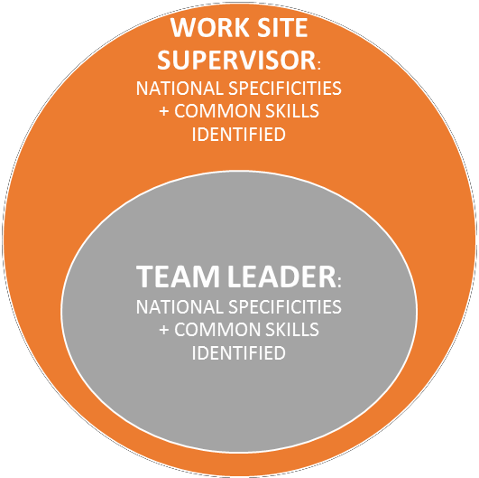
Whole Span
Specific Span
Specifically, a module that covers the issues that at least any intermediary command must know to guarantee the safety and health of the workers under their charge and of third parties who participate in the construction work.

The previous phase of the ConstructyVET project was based on the identification of company needs in terms of knowledge, skills and competence, especially transversal and soft, in line with the evolution of the jobs of worksite supervisor and team Leader. To carry out the Phase 2 of the project, it was very important to adopt common definitions, explanations and examples of each concept, especially by taking into account the definitions proposed for each concept used in the classification and development of each component associated to the soft and transversal skills identified in the previous phase. Thus, the basic concepts consist in the definitions, proposed to establish a common starting point in those elements that will be taken into consideration during the second phase of the project and which priority is determining the training modules that define the formative itinerary of the worksite supervisor and the team leader.

The first work consisted in the review of national training paths related to the profiles of worksite supervisors and team leaders. After that, the partners produced a matrix with legal references to a professional certificate or qualification, theoretical contents, experience needed, range of occupations, etc.

The second step consisted in a review and analyse of job offers, which main objective was to identify the companies' demands to the profiles under review. The method for the IO2: Each of the statements proposed in the job offers has been related to a soft- transversal skill to observe the most commonly present in the text of these jobs offers therefore the most demanded by the companies.

The third initial step was the compiled report of the answers and opinions collected further to individual interviews and work in focus groups, enabling the partners to build up, further on, learning itineraries based on:

- Trades-occupations-jobs corresponding to appropriate qualification levels in line with National Qualification Frameworks (NQF).
- Some technical, but mostly Soft/transversal skills pointed out by the companies as essential for worksite supervisors and team leaders.
- Indication of main contents for training.

THE IMPRESSIONS AFTER THE PILOT TRAINING

Once the survey has been carried out to the participants, intermediate managers for the most part, but also to other profiles whose projection (official or technical) is directed towards these profiles (team leader and project manager), it is time to review what is considered a good practice or a good decision or something that on the contrary would not be useful in the way to exercise the "cornerstone" of a construction work, which would be the role to play for these figures of key importance in the works of construction.

It has been reflected in the methodology used on the one hand the difficulties, fears, and training gaps of intermediate profiles in the construction sector. But not only this but how they have evolved over time, that is, from the moment in which the students begin the training and until the moment in which they finish it. This is collected through the survey conducted in these two phases.

PRETRAINING SURVEY

Data: 61 answered questionnaires.

Before starting the classroom training (4 days classroom training) there were distributed the questionnaire. And the main answers compiled at Google Forms will be reviewed below starting the introduction and instructions with a short description of the project and the aims “under its umbrella” in order to get the trainees attention focused on the companies needs about these middle management profiles.

First of all, the profiles distribution: Based on the total answers to the question

- “Position in company (if applicable)”. It is an open answer but once pooled the answers the WSS were around 18; TL 13; other: 14; and the remainder responses were in blank.

This means that the answers are balanced between TL and WSS but not only, because we must take in account the other positions that may reach the Middle Management position. I mean the first officers, for example, use to be experienced enough to accept the middle management position and they may help based on a 360º review and in a critical point of view.

- “Training contents”. This was one first question to estimate the previous knowledge in this subject (Health and Safety). In the questionnaire was integrated the three main topics covered in construction H&S training for workers at work sites. And it is interesting appreciate that only one answer integrate the three topics; the other sixty marking one, two or the third one but not all of them.

- “Why do you participate in the training? Almost half of the respondents were involved in the training because this is mandatory and their person in charge had sent them. Only one answer was referred to learn more or curiosity. And the most accepted answer was referred to “I need the skills – it will be useful for work”.

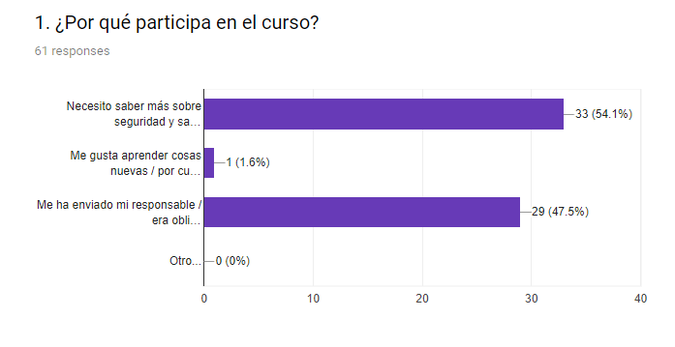

Around 50% of the trainees are obliged to enrol in this training, what mean that probably they have the experience to do the middle management work (technical knowledge, skills and competences in a specific craft) but under the companies needs they must complete that experience with key knowledge skills and competencies.

And next, the most important questions to determine the expectations of the trainees about a new path to access to the Middle Management positions we are studding.

- “What do you expect of the training”?

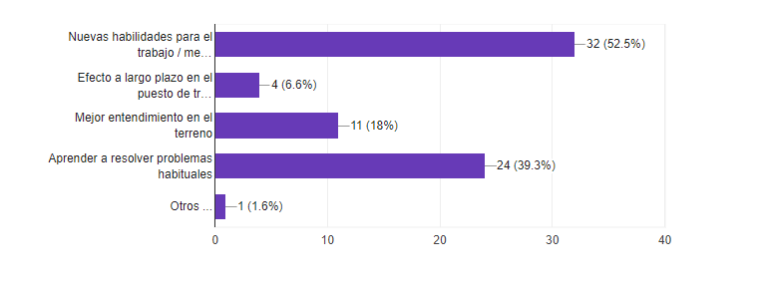

The most of the responses are related to an immediate acquisition of new skills for their work (“new skills for the job /increased effectiveness) and “learning how to solve typical problems”. Especially in Health and Safety issues this is important because there are daily challenges in this matter and the middle management need to coordinate all the different figures.
Based on the responses they seem to be very awareness of their responsibility and the role played but the expectation are focused in the short in time. The trainees do not think in this competences in the long term.

- What form do you think the training must be done?

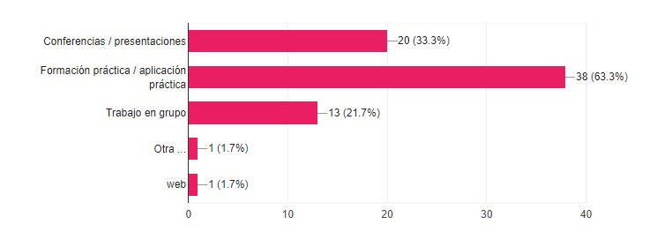

These answers are specially unexpected because the training is created as blended training and they all knew it. Probably this answer in combination with almost 50% of responses (“my employer sent me”), I mean, more than 60% of the respondents answered “practical training /simulation” but if they have been sent to the training by their employees it is reasonable that they would chosen a type of training that let the trainees work more hours and at the same time receive the needed training to acquire the demanded skills.

- What is the most important thing you expect from the training?

This is an open question with the possibility to answer freely. So about this question each answer is different to the others. But the fact is we extract from the total those responses more representative for the project aims.

Most of that answers contain the concept “learn” specifically learn about Health and Safety; technics to put in practice in a construction site; to understand the project phase and the application to a work site; to know about the rules and normative in this regard; so solve problems and know about the different type of measures used at a work site to protect the workers.

There are answers that include the legal knowledge needed in the construction sector and manage the issues related to H&S at construction.

And another type of answers including a more personal and individual interest as: applicability to their jobs or to improve in their careers. So the conclusion is that they have the perception of better conditions if they acquire better skills to develop their positions.

And a common conclusion in all the answers that is to put in practice at the work site everything learnt.

- Self-assessment. Would you meet the following requirements?
The first thing to do is to stablish the three LO in this transversal competence and decompose those in learning contents to be assessed by themselves. The answers are close to a very good acquisition of the contents. Conclusion extracted from the average of the total answers in this regard and in this stage of the training, I mean, they only have, in the moment of the survey, the contents, the schedule and the opportunity to review the learning material (pdf files at the virtual campus, exercises, examples…).

- PERSONAL DATA
And to close this pre-training survey analysis a brief check of the personal data.
In Spain this profile is common in terms of qualifications and the contents are the same for both (WSS and TL). This is the explanation to unify only in one class and sharing the contents. In special if the contents are related to Health & Safety. The most represented profile is the WSS but it is balanced.
One relevant data is the women participation in this training. There were around 11.5% of women that is still a low rate but anyway important in my opinion the representation of women because of their special capacity to manage soft skills.

POSTRAINING SURVEY

In this second survey 50 answered questionnaires.
- General feedback
This is interesting but not totally representative for the whole project results because the respondents in this specific LO are encompassed in Health and Safety.

The most remarkable thing based in these results is the connexion with the trainers and the good assessment to them. The personal compromise of the trainers to get the learning outcomes for the trainees is appreciate in a highly way for the respondents especially due to the blended method of learning in a sector highly oriented towards practice.
- Difficulty of the Assessment:
My interpretation of this question and in particular the answers is that both are focused on showing the perception of the trainees after the theoretical approach.

The scale in this occasion is from 1 (very easy) to 5 (very difficult) and all the answers were concentrated from the mid value (2.5) to the higher difficulty value (5). So, the difficulty is assessed over the average but this is logical if the trainers want to determine the level of competences acquisition. And the only remarkable is the assessment showed by trainees regarding the online practices as the most difficult type of assessment.

- Level of assessment of the test verifying the LO
The scale in this graphic is from 1 to 5 (being 1=”Not at all” and 5=”Yes, very much”) and as it can be showed below the answers were concentrated over 4 so the type of assessment exercises had received positive valuations based on the level of assessment in the techniques used.

- Was the time for assessment enough for you?
From 50 answers to this question, only 4 (less than 10%) answered NO. To these who answered no the next question:
- If no: Which parts would require more time? What could be improved?
The most of these answers were focused on the whole course and not only to the time to answer the questions. And the only answer in this regard issue is about the manner to do the question. In this case the consideration about the time is that it is enough. After that, in conclusion, they have had enough time to complete the different evaluation proofs.

- Assessment method used

This graphic is only to confirm the assessment methods used along the testing process that are four in different stadiums of the blended learning process.

- Self-assessment. Have you achieved the following learning outcomes?
Checking the following graphic and comparing it with the auto assessment one in the first part of this report the goals in terms of what the trainees look for in the course and what finally learn at the end of it seem to come together as you can see in below. I mean the

The conclusion after the review of the answers and comparing the pre and post survey the expectations at the beginning of the training have been met and verified based on the answers given.

One good image extracted from this pilot testing is based on the awareness shown by these profiles with responsibility about health and safety of their workers. Reflected in the expectations showed from the beginning regarding the learning outcomes proposed.

WORKSITE SUPERVISOR

- Main characteristics of worksite supervisor in the partner countries
In every country it was pointed out that worksite supervisors must have global and integrated vision of the worksite and of the staff placed under their responsibilities. Their first legitimacy is based on their solid technical and technological knowledge, plus environmental, health and safety standards and formal regulations, but even if it is essential, it is not considered as sufficient. In fact, the investigation demonstrates clearly that worksite supervisor must possess transversal and combined skills where many components are blended to give him capacities of anticipation, organisation, negotiations, communication (with customers, hierarchy and staff), controlling and speed reactions in complex situations. S/he must consider and manage worksites as projects by looking ahead and mobilizing people for the achievement of planned results. Human resources management is the aspect that becomes ever more complex and demands specific communication skills to make staffs adhere to the objectives given. Contacts with customers and subcontractors also gain in importance. Thus, his/her first competence is above all managerial with a level of complexity steadily increasing that includes management of resources of any kind, respect of contractual obligations and norms, as well dealing with a significant number of unforeseen situations. For all these reasons, work supervisors must be able to manage their own stress and to decrease stressful situations of their staffs.

- Main evolutions of the worksite environment and sustainable changes at worksite

Once again, the investigation results show clearly an increasing degree of complexity of the changing environment and work situations the worksite supervisors face in the partner countries. Steady cost pressure, more competition, ever shorter deadlines, as well as more and more formal regulations and new norms related to health and safety prescriptions, environmental and energy saving requirements, technical and technological change, as well as ICT evolution determine organisation and work conditions at worksites. Therefore, worksite supervisors must be able to adapt to new materials, new techniques, new standards, new methods and new organisations by getting regular information and appropriate training. The main change consists in the fact that worksite supervisors do not manage different means of production as a first goal of their activity, but they are in charge of respect of objectives in terms of contractual final results as agreed with customers, with respect of the means (human, financial and material) attributed.

- Participation in organisational, financial and human resources management

Worksite supervisors ae considered by their hierarchy as operational worksite managers with an increasing degree of autonomy and responsibility. They are in charge of process planning and scheduling, as well as of the organisation of appropriate means, in line with the instructions received from the head of the company. Within this framework, they rely on team leaders to coordinate workers. Their contacts with subcontractors and suppliers are increasing, as well as controlling activities.

But the core of their activity remains, according to the results of the investigation carried out, human resources management that becomes ever more complex given that the work itself becomes more and more complex from legal, technical, organisational, financial and human points of view.

Thus, as an operational manager at worksite, s/he is involved in the whole management of the production process, even if s/he follows the instructions given by hierarchy (total control over the project by using both responsibility and independence when managing worksites).

The activities of mediation (with staff, with clients and with other external partners) are also gaining in importance and become key actions, in parallel with activities of permanent controlling and final evaluation of contractual results. Besides, in many partner countries, worksite supervisors are more and more involved in financial planning as interface between company head office and operational level.

- Relationships between worksite supervisors and team leaders

The first aspect pointed out by the partners after the investigations is a mutual trust between worksite supervisor and team leaders as a necessary condition of a smooth organisation of activities. This demands from worksite supervisors to be good communicators, open minded and technically at the forefront. His/her legitimacy towards team leaders is based on clear hierarchical relation where s/he is fully recognised as skilled professional from technical, organisational and human points of view, capable to build up cohesion of staffs, to implement a good understanding of objectives to be achieved and to guarantee an efficient external/internal communication/mediation with all the partners and with hierarchy. Listening skills and capability to be understood and followed by team leaders are considered as essential to succeed in this function.

TEAM LEADER

- Main characteristics of a team leader
The main common characteristic pointed out by the project partners further to the investigations is the increasing requirement of autonomy at work with more and more pronounced leadership, as a principal support of worksite supervisor. Concerning other characteristics, transversal skills are tackled more frequently than technical competences. Both are necessary and technical knowledge remains a basis of the team leader legitimacy, but the interlocutors interviewed underline that technical aspects are easier to learn, whereas transversal skills are less linked to knowledge and depend more on abilities and professional/human behaviour. Thus, they stress the increasing importance of communication to understand and support workers, to control the production process and to evaluate results, as well as to make staff adhere to collective projects with their advantages and constraints. Otherwise, team leaders do not have to be only followers of the decisions taken by the others, but they must have the ability to foresee and to plan ahead. Besides, team leaders must be at ease in multifunctional environment with multiple activities, which demands comprehensive views of the construction process, independence and thoroughness (technical, normative, legal and organisational) with a certain will to manage and motivate people. His/her role is often difficult as s/he is at the same time a “chief” and a “fellow”. Therefore, s/he must be able to negotiate and to make accept his/her natural authority, with mutual respect and trust.

- Main evolutions of the worksite environment and sustainable changes at worksite

All the partners stress that worksites have become more complex nowadays and new requirements in terms of legislation and norms are more and more numerous. Moreover, technological, organisational and behavioural evolutions are very fast, which requires a great capacity of adaptation to changing contexts, where productivity with deadlines always shorter and quality always higher are the main criteria of performance for customers and for hierarchy. Besides, team leaders are more and more involved in administrative procedures to which they are not always well prepared. Today’s environment demands in fact not only an in-depth knowledge of technics and norms, but a new professional culture where energy saving, health & safety at work or ICTs are fully assimilated as steady components of activities undertaken.

- Participation in the organisation of the worksite

The first contribution of team leaders to the organisation of the worksite is to explain work and processes to their crew, including all the formal requirements. They also organise each worker’s tasks and proceed with quality check. By encouraging participative management of staffs, they listen to the workers and take into account their opinions when organising and controlling activities and final outcomes.

The degree of their autonomy has increased and they are more and more responsible for deadlines, problem solving, motivation of staff, safety & health, waste treatment, as well as for administrative and even for some financial aspects of their activities. Being “in the middle” between head office and directly operational level coordinated by worksite supervisor, team leader is gaining in importance on worksite and becomes a partner who really contributes to its organisation, given that s/he remains in charge of execution of the project and of coordination of his/her staff.

- Relationships between team leaders and other workers

In the partner countries team leaders are clearly situated as supervisors of their crews who have hierarchical legitimacy and authority. But they must chose themselves necessary means to make them respected by the workers, starting from their technical and technological knowledge, but also trough their transversal skills: especially communication, mediation, spirit of cooperation, motivation, conviction, as well as ability to make adhere to projects and activities. To build up positive relationship with other workers, team leaders must be open minded and attracted by mutual trust and confidence where potential conflicts could find positive end quickly. Main characteristics required therefore are: diplomacy, clarity, respect, natural authority, capacity of delegating and controlling, acceptance of criticism and capability of sending signs of recognition

