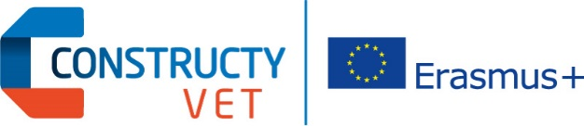

Middle Management Skills in the Building Sector:
Adjustment of the Vocational Education to the Evolution of Company Needs
Contract: 2015-1-FR01-KA202-015054

METHODOLOGY, INSTRUCTIONS AND WORKING MATERIALS FOR PHASE 4:

MODEL FOR COMBINED EVALUATION AND RECOGNITION
OF LEARNING OUTCOMES

Phase Leader: IBE - Educational Research Institute (PL)
Prepared with feedback from Marek Ławiński, CCCA-BTP (FR)

Table of contents:

1. Introduction 3
1.1. Why is combined model for evaluation needed? 3
1.2. The link between phase 3 and 4 3
2. Methodology for combined evaluation of learning outcomes 5
2.1. Methodological background of the model 5
2.2. Subject of the combined evaluation model 6
2.3. Practical tools for the combined evaluation 7
3. Assessment 8
3.1. Common understanding of assessment 9
3.2. List of assessment methods: 10
3.3. Selecting assessment methods for learning outcomes 11
4. Surveys and interviews 12
5. Chronology of actions 13
Annex 1. Pre-training survey 14
Annex 2. Post-training survey 16
Annex 3. Post-assessment survey 20
Annex 4. Interview scenario – participants 23
Annex 5. Interview scenario – partners 30

Introduction

The main aim of phase 4 is to develop and test the Model for combined evaluation and recognition of learning outcomes. In previous phases we have developed a list of modules, learning units and learning outcomes with assessment criteria, as well as pedagogical methods and tools for (re)designing VET paths.

The work in phase 4 will involve analysing the learning outcomes from different perspectives, answering the following questions:
- are the learning outcomes being delivered in training?
- are the learning outcomes being properly assessed?
- are the learning outcomes fit/useful for workers/trainees and employers?

We will look at training, assessment and satisfaction of stakeholders with learning outcomes in mind.

Why is combined model for evaluation needed?
“(…) the experience piled up by the partner organisations demonstrates that it (evaluation) is often limited to its formal or legal aspect. Therefore, the partners propose a more exhaustive and combined evaluation focussed(...),
- on the companies and on the individuals, related to the field of motivation, usefulness, recognition and certification of qualification and, (…)
- on the related VET system, which adds (…) a more global dimension.

In fact, (…) formal evaluation of learning outcomes (…) is often regulated and supervised, whereas all the other forms of evaluation are often blurred and rarely systematic.

For this reason, the partners intend to set up (…) an experimentation of the training actions that will be renewed or created, which would (…) be a field to elaborate a pragmatic and complex model for the evaluation of the VET actions, by confronting concepts with real final end users of the schemes conceived (individuals and building companies).

(…)The objective is to (…) [prepare a] proposal for the evaluation of the transversal skills specific to the middle management staff in the building companies, starting from the VET experience made with team leaders and worksite supervisors. (…) It will include national and transnational capitalisation of rules and situational experiences to prepare a more collective research of common solutions to be proposed as a new model”

The link between phase 3 and 4

The outcome of phase 3 are: Guidelines for pedagogical methods and tools for (re)designed VET paths addressing both VET centres and company tutors and also including instructions and recommendations for accompaniment of the learning process.

Phase 4 opens the experimentation process in which the outcomes of phase 3 will be put to practice. The focus of the phase is on evaluation of learning outcomes. Three main outcomes of the phase are:
- Implementation of the experimentation in VET paths;
- Conception and testing of the combined evaluation model;
- Gathering feedback and finalizing the combined evaluation model.

Methodology for combined evaluation of learning outcomes

The model is a theoretical framework and a set of tools for increasing quality of learning, qualifications significance and stakeholders satisfaction with learning outcomes. The model helps in evaluation of training based on learning outcomes.

It is developed for and by sectoral organizations dedicated to increasing quality of learning, qualifications significance and stakeholders satisfaction. The end beneficiaries of the tool are trainees/learners and employers.

The underlying assumption of the model is that, without cooperation there is no Quality. Using the tool will require coordination with the following actors:
- Organizations/experts responsible for definitions of learning outcomes,
- Training organizations and staff,
- Assessing and certification bodies,
- Learners/trainees,
- Employers.

Methodological background of the model
The model draws from Kirkpatrick's Four-Level Training Evaluation Model for Analyzing Training Effectiveness. The four levels are briefly presented in Figure 1.:

Figure 1. Four levels of evaluation of training

The four levels indicated in the original methodology have been adjusted to fit in the context (and limitations) of project – to evaluation of learning outcomes. As a result we have a combined approach, which takes into account both the learning outcomes and training perspective.

Figure 2. Four levels of evaluation of learning outcomes and training

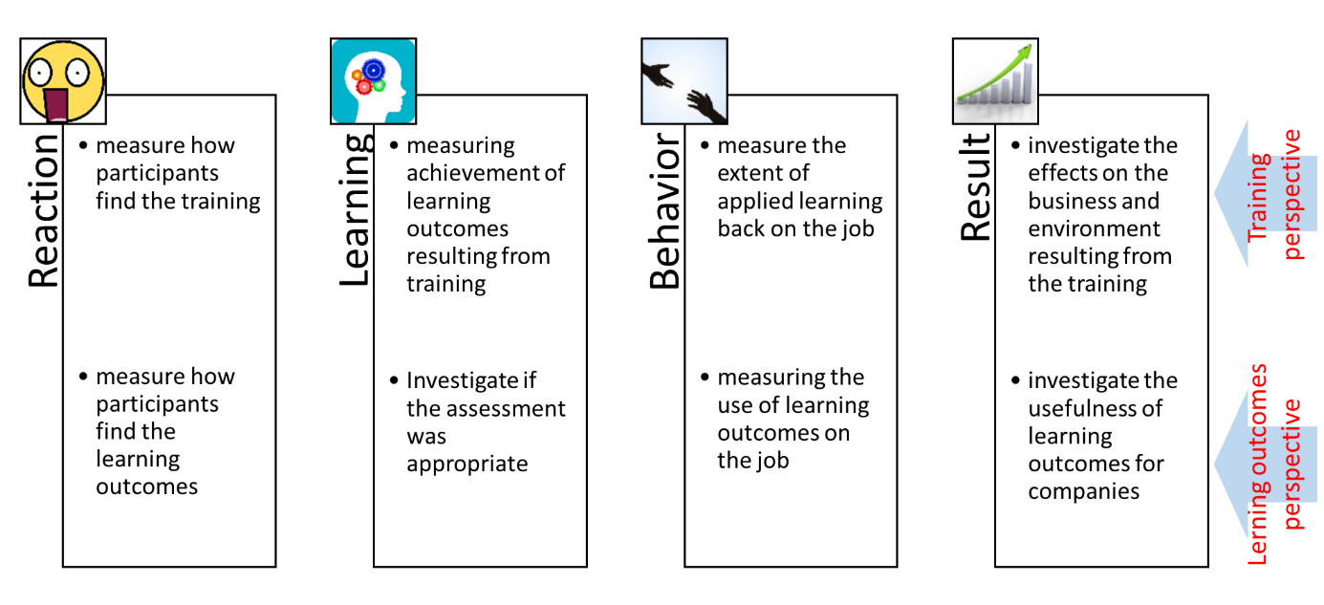

Subject of the combined evaluation model

The following key aspects of the learning outcomes will be the subject of evaluation:
  - Assessment of learning outcomes
    - Achievement of new skills (learning outcomes)
    - Choice of assessment methods
    - Quality of assessment
  - Environment impact
    - Learners and employers satisfaction
    - Usefulness of new skills on jobs
  - Training provision
    - Choice of training methods and pedagogical tools
    - Organization of learning

Figure 3. Model for Combined evaluation and recognition of learning outcomes
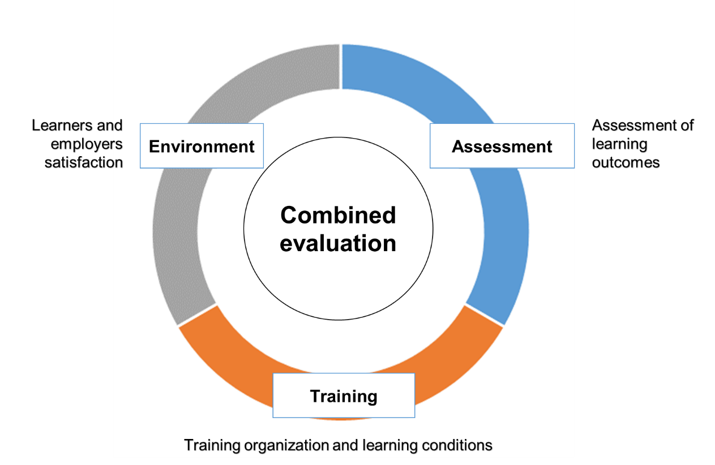
Source: own work.

Practical tools for the combined evaluation

A good judgment requires having the right distance and looking from different perspectives (triangulation).

In order to provide a thorough evaluation, we will use three basic tools:
- Surveys – for analyzing reactions of participants, their self-assessment of progress made, perceived usefulness of learning outcomes (etc.).
- Interviews – for analyzing the results and changes in behavior. Among others, we will ask about the observations and level of satisfaction of employers and participants.
- Assessment of learning outcomes – for analyzing if learners have mastered the knowledge, skills and competences and, to some extent, also the effectiveness of training. This tool refers to the examinations (and other methods) used by partners in experimentation phase.

Common terminology and guidelines for choice of assessment methods are presented in part 3 of this document.

The planned surveys and interviews are presented in part 4. The surveys are presented in Annexes.

Note: These tools will be used for combined evaluation of learning outcomes. But at the same time, one of the aims of the project is improving and experimenting with assessment methods of learning outcomes. This will require critical reflection on the assessments conducted by partners, for example on the: organization, methods and results of assessment of learning outcomes for analyzing the improvement of skills, training quality, accuracy of assessment methods.

Assessment

Part of our task is to analyse the organization and results of assessments of learning outcomes, as well as the methods of assessment used.
- For analysing the organization you can use the outcomes of the appropriate survey (post-assessment survey) and results of phase 3.
- For analysing the results of assessment, you will be asked to provide a synthetic/summative information about the “success rate”, question / tasks on assessment etc. (details to be provided). Much of this information is/will be collected in phase 3.
- For analysing the accuracy / appropriateness of the assessment methods you can use the information presented below (especially in point 3.2. and 3.3.).

Part 3.1. provides common understanding of assessment – this is necessary for building understanding and communicating project results to external stakeholders.

Part 3.2. presents the proposed list of assessment methods, which classifies the most often met forms of gathering evidence if learners mastered learning outcomes. This is building common terminology for discussing assessment.

Part 3.3. discusses the problem of matching assessment methods with learning outcomes, using examples from the project. This part is intended as a material helpful in analysing if the assessment methods used in experimentation have been appropriate / accurate for the learning outcomes.

Common understanding of assessment

Assessment of learning outcomes is a process leading to confirmation if a person has achieved the requirements specified in a standard.

In case of ConstructyVET project, this standard are learning outcomes and assessment criteria. Depending on the outcomes, different assessment methods can be used.

There is no one catalogue of assessment methods, the material presents a proposed list of names assessment methods to be used in ConstructyVET project.

The ConstructyVET project intends assessment for each unit, because, it increases the value of the training and certificate (it’s not a certificate of attendance but a certificate of competency!).

The part of the document is intended to provide common vocabulary for partners to discuss the issues of relation between learning outcomes and assessment.

Assessment methods have to be carefully selected and applied. A transparent, thorough and fair assessment motivates to workers and pupils to learn and develop.

This material is also intended to help in final selection of assessment methods as well as evaluation of the assessment methods used in experimentation.

List of assessment methods:

Table 1. List of assessment methods
Methods | Description / assessment tools
- Oral examination | Usually an interview with scenario (question list).
- Written examination  - Open ended questions  - Multiple choice questions  - Written task | A test with open ended questions or multiple choice questions. Often also larger tasks, such as solving a complicated case study or preparing documentation.
- Presentation | Usually presenting a self-prepared material multimedia presentation, poster to an audience.
- Observation in simulated conditions | Observation of realization of task in simulated conditions or persons’ behaviour in simulation games/tasks, group work projects, etc.  Both the process and outcome can be subject of assessment
- Observation in real conditions | Work-place observation with list of criteria. 360 degree assessment.  Both the process and outcome can be subject of assessment
- Outcome/product analysis | Assessment of prepared product (element, document) or result of a service.  No analysis of process involved.
- Dossier/portfolio analysis | Assessment of declarations and documents presenting previous experience and achievements.
Source: own work using:
- Educational Research Institute publication entitled “Walidacja. Nowe możliwości zdobywania kwalifikacji” [Validation. New opportunities for attaining qualifications];
- European Inventory on validation of non-formal and informal learning, update 2016 (http://www.cedefop.europa.eu/en/events-and-projects/projects/validation-non-formal-and-informal-learning/european-inventory)

Selecting assessment methods for learning outcomes

Usually to confirm if a person has achieved a learning outcome more than one method of assessment can be used.

The general rule of thumb is: For practical learning outcomes select practical assessment methods.

The difference between ‘knowing how to do something’ and ‘doing it’ is key. If the outcome is about ‘talking’, the assessment should involve talking, and if the outcome is about ‘doing’ something, the assessment should involve doing it (not just talking about how it should be done).

In case of soft skills, it will not always be possible to have one, final (summative) assessment at the end of the training. These skills require innovative approach, and using new, in some context, experimental methods.

For example some communication skills can be:
- assessed based on evidence collected during training (e.g. video of a person using negotiation techniques);
- assessed based on a 360 degree assessment, which involves talking to co-workers about changes in communication of the assessed person.

Table 2. Examples of relation between learning outcomes and assessment methods
Learning outcome | Assessment methods | Comments
Prepare and conduct a meeting | - Analysis of product/outcome (such as prepared agenda and materials for the meeting)  - Observation in simulated conditions (a group work project during assessment center)  - Observation in real conditions (during a work meeting) | Analysis of prepared agenda and materials does not provide full proof of achievement of learning outcome, since it only proves the ability to prepare a meeting (as opposed to prepare and conduct).  Observation in real conditions is usually the best method, but also the most expensive one.
Explains the risks related to cooperants failure to deliver goods or services | - Oral examination (including answering questions related to selected risks)  - Written examination (open ended question ‘explain the …’) | Both written and oral examinations are suitable to assess the ability to explain risks.
Implement the procedures, from the documentation of the work and applying the rules of hygiene, safety and health protection at work. | - Observation in real conditions (visit on construction site and assessment of the extent of application of the procedure)  - Oral examination based on documentation and case analysis (with specific questions about ways to implement procedures and safety measures in given conditions); | Oral examination is possible, but it can be questioned whether it takes into account the implementation and application (…) at work.  Note that if the outcome was “explains procedures for (…)” completely different methods could be applicable.

Surveys and interviews

This part of the document outlines the concept for collecting feedback with the use of surveys and interviews in phase 4 of the ConstructyVET project.

These instruments will be used to evaluate:
- the satisfaction with the proposed contents, perceived usefulness of the training and participants motivation; and overall satisfaction with participation in the course;
- quality of assessment of learning outcomes;
- probable effects of training on business and environment (measuring them exceeds the project timeframe);
- possible improvements of the training methods and contents;
- organizational and other factors influencing the training.

Table 3. List of proposed surveys and interviews (in order of use):
Name | Main aspects analyzed:
- “Pre-training survey” for all participants of training | Reasons for participation;  Expected results;  Self-assessment using list of outcomes proposed
- “Post-training survey” for all training participants directly after training | Realization of training goals;  Meeting expectations;  Self-assessment using list of outcomes proposed;  Choice of contents;  Possible improvements;  Organization of training.
- “Post-assessment survey” for after examination | Were all outcomes tested  Were people informed about the assessment
- Interviews with training participants | Usefulness of skills in workplace (examples);  Self-assessment using list of outcomes proposed;  Possible improvements;
- Interviews with partners (employers, cooperants – who had to do with trainees) | Usefulness of skills in workplace (examples);  Assessment of trainee skills using list of outcomes proposed;  Relevance of training for needs in workplace
*In some cases training and assessment may be organized on one day, in that case one, combined survey can be used.

The proposed content of surveys and interview scenarios are presented in Annexes.

Chronology of actions

The evaluation takes place at different moments in relation to the formation, assessment and use of learning outcomes. The general representation of this is presented in figure 4 below:

Figure 4. Chronology of formation, assessment and use of learning outcomes.
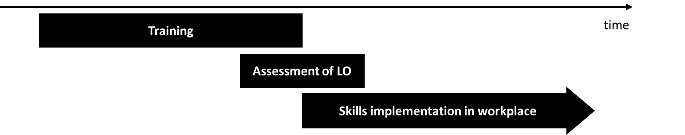
Souce: own work

Please note that the assessment can very often be a point in time, but it can also take longer time for presenting achievement of some skills (e.g. collection of evidence). In some cases it can begin during the training process.

The figure below presents the moment of use of selected evaluation tools.

Figure 5. Chronology of evaluation actions in ConstructyVET project.
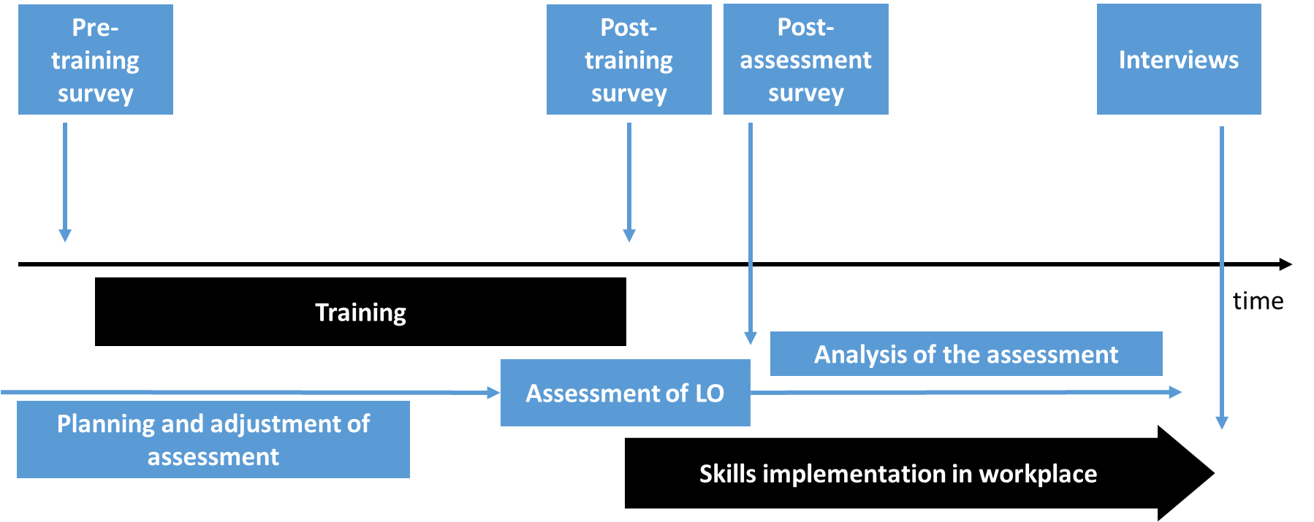

Source: own work.

In order to assess the whole process of formation, assessment and use of learning outcomes we need to look at different moments in the process. For example:
- the pre-assessment of the learning outcomes is only possible before the training. Without this we will not know if the learners achieved the skills as a result of training or, perhaps, already had the skills and only needed to confirm that;
- the use of learning outcomes in the workplace can only be assessed after a certain period of time – e.g. 2 months after the training.

Annex 1. Pre-training survey

Middle Management Skills in the Building Sector:
Adjustment of the Vocational Education to the Evolution of Company Needs
Contract: 2015-1-FR01-KA202-015054

PRE-TRAINING SURVEY
Phase IV

Introduction

This is a survey for evaluation of pilot training in ConstructyVET project, please answer the following questions, so that we can improve the training provided in the future.

Learning unit title: _________
Date and place: _________
Trainer(s) name(s): _________

- Why do you participate in the training? (multiple choice)

I need the skills – it will be useful for work
I like to learn new things / out of curiosity
My employer sent me / it was obligatory
Other: _____________

- What do you expect of the training?

OUTCOMES
New skills for the job / increased effectiveness
Long term effect on job position
Better understanding of the field
Learning how to solve typical problems
Other: ____________
FORMS
Lectures / presentations
Practical training / simulation
Group work
Other: _____________

What is the most significant competence, that you expect of the training?

- Self-assessment. Would you meet the following requirements?
[fill in before doing the survey: please put in the learning outcomes for the unit]

 | Not at all |  |  |  | Yes
[insert LO 1] | 1 | 2 | 3 | 4 | 5
[insert LO 2] | 1 | 2 | 3 | 4 | 5
[insert LO 3] | 1 | 2 | 3 | 4 | 5
[insert LO 4] | 1 | 2 | 3 | 4 | 5
(…) | 1 | 2 | 3 | 4 | 5

- Age: _____________

- Sex: _____________

- Position in company (if applicable): _____________

- Years of experience: _____________

- Year of organized education (school, studies, apprenticeship etc) in the field of construction: _____________

Annex 2. Post-training survey

Middle Management Skills in the Building Sector:
Adjustment of the Vocational Education to the Evolution of Company Needs
Contract: 2015-1-FR01-KA202-015054

POST-TRAINING SURVEY
Phase IV

Introduction

This is a survey for evaluation of pilot training in ConstructyVET project, please answer the following questions, so that we can improve the training provided in the future.

Learning unit title: _________
Date and place: _________
Trainer(s) name(s): _________

General feedback:
Please assess below-listed components using the scale from 1-poor to 4 excellent/very useful:
 | Poor |  |  | Excellent/  Very useful
Overall Verdict | 1 | 2 | 3 | 4
Training Structure | 1 | 2 | 3 | 4
Training Content | 1 | 2 | 3 | 4
Theory was supported by practice | 1 | 2 | 3 | 4
Trainer(s) | 1 | 2 | 3 | 4
Venue | 1 | 2 | 3 | 4
Pace of Training | 1 | 2 | 3 | 4
I had fun | 1 | 2 | 3 | 4
I learnt something useful | 1 | 2 | 3 | 4
I am glad I came | 1 | 2 | 3 | 4
Training vs. expectations | 1 | 2 | 3 | 4

- Did the training help you develop the following competences?
[fill in before doing the survey: please put in the learning outcomes for the unit]

 | Not at all |  |  |  | Yes, very much
[insert LO 1] | 1 | 2 | 3 | 4 | 5
[insert LO 2] | 1 | 2 | 3 | 4 | 5
[insert LO 3] | 1 | 2 | 3 | 4 | 5
[insert LO 4] | 1 | 2 | 3 | 4 | 5
(…) | 1 | 2 | 3 | 4 | 5

- Which outcomes do you think will be useful for your work?
[fill in before doing the survey: please put in the outcomes for the unit]

 | Not at all |  |  |  | Yes, very much
[insert LO 1] | 1 | 2 | 3 | 4 | 5
[insert LO 2] | 1 | 2 | 3 | 4 | 5
[insert LO 3] | 1 | 2 | 3 | 4 | 5
[insert LO 4] | 1 | 2 | 3 | 4 | 5
(…) | 1 | 2 | 3 | 4 | 5

- What else/next would like to learn?
Please be as specific as possible

- Self-assessment. Have you achieved the following learning outcomes?
[fill in before doing the survey: please put in the outcomes for the unit]

 | Not at all |  |  |  | Yes
[insert LO 1] | 1 | 2 | 3 | 4 | 5
[insert LO 2] | 1 | 2 | 3 | 4 | 5
[insert LO 3] | 1 | 2 | 3 | 4 | 5
[insert LO 4] | 1 | 2 | 3 | 4 | 5
(…) | 1 | 2 | 3 | 4 | 5

- Which teaching/learning forms did the training consist of?
Put an “X” in one or more of the columns
 | Yes | No
Lecture / presentation;
Practical training / simulation;
Group work;
Other: ___________
Other: ___________

- To what extent do you agree with the following statements?
Please leave a comment if you rate 1 or 2
 | Not at all |  |  |  | Yes, very | Additional comments
The goals of the training were clearly defined | 1 | 2 | 3 | 4 | 5
The covered topics were relevant to course | 1 | 2 | 3 | 4 | 5
Training materials were well prepared | 1 | 2 | 3 | 4 | 5
Methods of training were relevant for the training goals | 1 | 2 | 3 | 4 | 5
The training time was just right | 1 | 2 | 3 | 4 | 5 | Too long / short  (please indicate)
The course content was simple and understandable | 1 | 2 | 3 | 4 | 5
The trainer actively involved me in the process | 1 | 2 | 3 | 4 | 5

- What could be improved / changed?
Please be as specific as possible

- Age: _____________

- Sex: _____________

- Position in company (if applicable): _____________

- Years of experience: _____________

- Year of organized education (school, studies, apprenticeship etc) in the field of construction: _____________

Annex 3. Post-assessment survey

Middle Management Skills in the Building Sector:
Adjustment of the Vocational Education to the Evolution of Company Needs
Contract: 2015-1-FR01-KA202-015054

POST-ASSESSMENT SURVEY

Phase IV

Introduction

This is a survey for evaluation of pilot training in ConstructyVET project, please answer the following questions, so that we can improve the assessment provided in the future.

Learning unit title: _________
Date and place: _________
Trainer(s) name(s): _________

General feedback on assessment:
Please assess below-listed components using the scale from 1-poor to 4 excellent/very useful:
 | Poor |  |  | Excellent/  Very useful
Overall Verdict | 1 | 2 | 3 | 4
Assessment Structure | 1 | 2 | 3 | 4
Questions / tasks were understandable | 1 | 2 | 3 | 4
Questions / tasks verified relevant knowledge and skills | 1 | 2 | 3 | 4
Assessors | 1 | 2 | 3 | 4
Venue | 1 | 2 | 3 | 4
Assessment vs. expectations | 1 | 2 | 3 | 4

- Difficulty of the assessment:
Please indicate if the assessment was easy or difficult for you in a scale from 1-very easy to 5-very difficult:
[note to partners – please indicate parts of assessment if relevant
(example part 1 – written test; part 2 – practical exam/simulation; or part 1 – multiple choice questions, part 2 – open ended questions)]
 | Very easy |  |  |  | Very difficult
Part 1 | 1 | 2 | 3 | 4 | 5
Part 2 | 1 | 2 | 3 | 4 | 5
[Part 3, etc.] | 1 | 2 | 3 | 4 | 5

- Did the assessment test/verify the following competences?
[fill in before doing the survey: please put in the learning outcomes for the unit]
 | Not at all |  |  |  | Yes, very much
[insert LO 1] | 1 | 2 | 3 | 4 | 5
[insert LO 2] | 1 | 2 | 3 | 4 | 5
[insert LO 3] | 1 | 2 | 3 | 4 | 5
[insert LO 4] | 1 | 2 | 3 | 4 | 5
(…) | 1 | 2 | 3 | 4 | 5

- Was the time for assessment sufficient for you (for preparing and answering questions, solving problems, presenting competences etc)?
Yes / No
If no: Which parts would require more time? What could be improved?

- Were you informed about the form(s) of assessment in advance?
Yes / No
If yes: how many days in advance?

- Were you informed about the criteria for assessment in advance?
Yes / No
If yes: how many days in advance?

- Were the assessors competent in the field?
Yes / No
If no: what competence did they lack?

- Was the venue right for the assessment?
Yes / No
If no: what equipment / qualities did it lack?

- Which assessment methods were used:
Put an “X” in one or more of the columns
 | Yes | No
Multiple choice questions;
Single choice questions;
Open questions;
Practical tasks / simulation;
Analysis of presented work;
Observation during training;
Observation in workplace;
Other: ___________

- Self-assessment. Have you achieved the following learning outcomes?
[fill in before doing the survey: please put in the outcomes for the unit]

 | Not at all |  |  |  | Yes
[insert LO 1] | 1 | 2 | 3 | 4 | 5
[insert LO 2] | 1 | 2 | 3 | 4 | 5
[insert LO 3] | 1 | 2 | 3 | 4 | 5
[insert LO 4] | 1 | 2 | 3 | 4 | 5
(…) | 1 | 2 | 3 | 4 | 5

- What could be improved / changed?
Please be as specific as possible

- Age: _____________

- Sex: _____________

- Position in company (if applicable): _____________

- Years of experience: _____________

- Year of organized education (school, studies, apprenticeship etc) in the field of construction: _____________

Annex 4. Interview scenario – participants

Middle Management Skills in the Building Sector:
Adjustment of the Vocational Education to the Evolution of Company Needs
Contract: 2015-1-FR01-KA202-015054
Interviews with training participants

Aim: to analyze the learning outcomes and quality of provided training on Middle Management Skills in the Construction Sector

Target group: persons trained and assessed in the project

Data and place: ___________________

Before the interview:
- Insert learning outcomes in the places marked with red font;
- Be prepared to remind the respondent about the training, date, time, place, etc.;
- Have the list of learning outcomes and description of assessment in handy, you might need to refer to it during the interview.

Part 1: Preliminary part - presentation of the Moderator and the participant

Moderator:

Good morning/afternoon,
My name is ______________________ and I represent____________________________________ .
We meet on this interview to get your opinion on the learning outcomes, quality of training and assessment in the project Middle Management Skills in the Construction Sector that you’ve participated in ____ months ago.
I would like to ask you some questions about the usefulness and effectiveness of training and assessment.

Moderator:

During this meeting I will ask you number of questions. Please do not hesitate to express any opinion about the training or assessment. All your feedback will be extremely important and valuable for drawing up the final report and for improvements. I would like to record today 's meeting and ask for your permission. Do you agree?

Moderator:
Please introduce yourself briefly.

Name and surname:
Current position in the company:
Name of the company:
Country/ town of employment:
Experience in construction sector: | Clarifications for respondent, if needed: What did you do in construction sector and for how long? How many years of experiences do you have in construction sector?
How many years of organized education in the field of construction do you have?  School/University: | Clarifications for respondent, if needed: In which/what kind vocational school, college or university?
Attended courses and trainings:

Part 2 : Questions about the training and assessment

Moderator:

Let's move on to the main purpose of this meeting, which is to collect comments on the quality of the training and assessment. Please share with me your opinion about the training and assessment. We will start with questions about the training.
- What were the strengths of the training:
Clarifications for respondent, if needed: What elements were better compared to other trainings he/she has been through. Which elements would he/she like to see more of in other trainings?

- What were the weaknesses of the training?
Clarifications for respondent, if needed: What elements were worse compared to other trainings you have been through. Which elements would you like to see less of in other trainings?

- What was the most valuable part of the training?
Clarifications for respondent, if needed: Which topic, which unit of learning you find most useful?

- What could be improved in the training?
Clarifications for respondent, if needed: Which parts of the training? You can refer to training forms, trainers skills, materials given, location of the training, duration, the topic of the training, etc.

- Name one thing you learned in the course that surprised you:
If the respondent has nothing to name, move on to next question. Do not suggest anything.

- What is your overall opinion about the training?
Clarifications for respondent, if needed: Please describe if it was useful or not, good quality training or low quality? Ask for descriptive feedback. If the respondent has problems expressing overall opinion, ask how would he/she rate it on a scale 1-10 (where 1 is very bad and 10 excellent)

Part 3 : Usefulness of skills in workplace

Moderator:
Now please let’s focus on usefulness of acquired skills in workplace. Tell me please:

- Do you use the skills and knowledge in workplace?
Clarifications for respondent, if needed: If yes, how often? Every day, every week, once a month, never? Can you give examples of situations when you had a chance of using the skills and knowledge in workplace?

- Do you use acquired skills in relation to co-workers/ subordinates?
Clarifications for respondent, if needed: Or maybe in private situations?

- Describe at least one specific thing you learned on the training that you used in your job:
Information for the interviewer: ask for a description, not just a statement such as ‘I used it to deal with my boss’.

- Name one thing you think you will use in your job, but did not use yet:

- In what way did the training help in your personal and professional development?
Clarifications for respondent, if needed: Did the training help you develop new skills, improve them, refresh (which ones?) or systematized knowledge? Did it increase your self-consciousness, self-confidence?

- Do you think your company has benefitted from the training?
Clarifications for respondent, if needed: what kind of benefits?

- Have you noticed any change in your relationships with co-workers/ subordinates after the training?
Clarifications for respondent, if needed: please give examples of situations.

Part 4: About the assessment of LO
Moderator: Thank You, now we will move on to your opinion about assessment:
- What were the strengths of the assessment:
Clarifications for respondent, if needed: Which qualities or parts of assessment contribute to a trustworthy, thorough and accurate assessment? The answer can refer to assessors, organization/location, duration, assessment methods, difficulty of assessment, task/questions asked, information about the assessment prior to it, etc.

- What were the weakness of the assessment?
Clarifications for respondent, if needed: Which qualities or parts of assessment undermine the trustworthiness, thoroughness and accuracy of the assessment? The answer can refer to assessors, organization/ location, duration, assessment methods, difficulty of assessment, task/questions asked, information about the assessment prior to it, etc.

- Would you say the assessment was accurate?
Clarifications for respondent, if needed: For example have practical skills been assessed in practice? Did the assessment confirm the skills listed as goals for the training. If the respondent does not know the learning outcomes, show him the list of learning outcomes, in order to answer the questions.

- Do you have suggestions for improving the assessment?
Clarifications for respondent, if needed: The suggestions can relate to assessors, organization/ location, duration, assessment methods, difficulty of assessment, task/questions asked, information about the assessment prior to it, etc.

- What is your overall opinion about the assessment
Clarifications for respondent, if needed: Please describe if it was trustworthy or not, good quality or low? Ask for descriptive feedback. If the respondent has problems expressing overall opinion, ask how would he/she rate it on a scale 1-10 (where 1 is very bad and 10 excellent)

Part 5 : Self-assessment after the training

Moderator: Thank You for all the answers so far. Now I would like to ask You for a self-assessment of skills:

- Have you achieved the following learning outcomes?
[fill in before doing the survey: please put in the outcomes for the unit]

 | Not at all |  |  |  | Yes
[insert LO 1] | 1 | 2 | 3 | 4 | 5
[insert LO 2] | 1 | 2 | 3 | 4 | 5
[insert LO 3] | 1 | 2 | 3 | 4 | 5
[insert LO 4] | 1 | 2 | 3 | 4 | 5
(…) | 1 | 2 | 3 | 4 | 5
Note for interviewer: The respondent might ask for clarification about the learning outcomes. Please note which outcomes required clarifications. And what kind of questions were asked.
Interviewer notes about questions concerning learning outcomes:

- What did you hope to achieve with this training:
Clarifications for respondent, if needed: what kind of skills, what job-related benefits, etc.

Other, general comments and conclusions of the participant:

General conclusions and comments of the interviewer:
(to be completed immediately after the interview)

Annex 5. Interview scenario – partners

Middle Management Skills in the Building Sector:
Adjustment of the Vocational Education to the Evolution of Company Needs
Contract: 2015-1-FR01-KA202-015054
Interviews with partners

Aim: to analyze the learning outcomes and quality of provided training on Middle Management Skills in the Construction Sector

Target group: employers, cooperants,

Data and place: ___________________

Before the interview:
- Insert learning outcomes in the places marked with red font.
- Be prepared to briefly describe the purpose and the scope of training and its short characteristics
- Have the list of learning outcomes and description of assessment in handy, you might need to refer to it during the interview.

Part 1: Preliminary part - presentation of the Moderator and the interviewee

Moderator:

Good morning/afternoon,
My name is ______________________ and I represent____________________________ .
We meet on this interview to get your opinion on the learning outcomes, quality of training and assessment in the project Middle Management Skills in the Construction Sector that your partner (cooperant, employer, employee) has participated in ____ months ago.
I would like to ask you some questions about the usefulness and effectiveness of training and assessment.

Moderator:

During this meeting I will ask you number of questions. Please do not hesitate to express any opinion about the trainee or the relevance of training for needs in workplace. All your feedback will be extremely important and valuable for drawing up the final report and for improvements. I would like to record today 's meeting and ask for your permission. Do you agree?
Moderator:
Please introduce yourself briefly.

Name and surname:
Name of the company/ institution:
Current position in the company:
Country/ city:
Interaction with participants of the training | Clarifications for respondent, if needed: have you cooperated with persons participating in the experimental training (after the training)? In what situations, roles did you interact with them?
Involvement in the experimental training | Clarifications for respondent, if needed: have participated in the training as lecturer/trainer, have you consulted the learning outcomes, helped in recruitment of the trainees (etc.)?

Part 2 : Questions about the overall assessment of the usefulness of the training

Moderator:

Let's move on to the main purpose of this meeting, which is to collect comments on the overall assessment of the training and its usefulness. Please share with me your opinion about
- What is your opinion about the training:
Clarifications for respondent, if needed: is it needed or not? Why?

- What do you think are main benefits of the training for partners (co-workers, cooperants) and employers?
If the respondent has nothing to name, move on to next question. Do not suggest anything.

- Have you received any feedback from your worker/partner who participated in the training?
Clarifications for respondent, if needed: Has a trainee referred to training forms, trainers skills, materials given, location of the training, duration, the topic of the training, etc.

Part 3 : Assessment of trainee’s skills

Moderator:
Now please let’s focus on the assess of trainee’s skills acquired on the training. First I would like to ask about new skills, improved/developed skills and how these matched with your previous expectations.
- Have the trainee(s) acquired new skills after this training?
Clarifications for respondent, if needed: If yes, name this skills. Are these skills useful at work?

- Has a trainee improved the competences that she/he already possessed?
Clarifications for respondent, if needed: If yes, name this skills. Are these competences useful at work?

- What skills/ competences you expected a trainee to achieve?
Clarifications for respondent, if needed: Has it met your expectations? In what areas? Was there something missing? Do not accept vague answers such as “it was too general” or “I thought it would be more practical”. Ask for specific examples of expected outcomes – you can ask “what new things did you expect the person to be able to do after the training?” or “what changes in the behavior did you expect?”.

- Please give your opinion about skills of the trainee you cooperated with. Assess the trainee skills before and after the training:
Before training |  |  |  |  | Skills acquired by the trainee | After training
1 | 2 | 3 | 4 | 5 | [insert LO 1] | 1 | 2 | 3 | 4 | 5
1 | 2 | 3 | 4 | 5 | [insert LO 2] | 1 | 2 | 3 | 4 | 5
1 | 2 | 3 | 4 | 5 | [insert LO 3] | 1 | 2 | 3 | 4 | 5
1 | 2 | 3 | 4 | 5 | [insert LO 4] | 1 | 2 | 3 | 4 | 5
[fill in before doing the survey: please put in expected skills] Note for interviewer: The respondent might ask for clarification about the skills. Please note which outcomes required clarifications. And what kind of questions were asked.
Interviewer notes about questions concerning learning outcomes:

- In what way did the training help in personal and professional development of a trainee?
Clarifications for respondent, if needed: Did the training help develop new skills, improve them, refresh (which ones?) or systematized knowledge? Did you notice the increase of his/her self-consciousness, self-confidence?

Part 4: Usefulness of skills in workplace
Moderator: Thank You, now we will move on to your opinion about the usefulness of skills acquired by a trainee:

- Do you think your company has benefitted from the training?
Clarifications for respondent, if needed: what kind of benefits?

- Does the trainee(s) use the skills and knowledge in workplace?
Clarifications for respondent, if needed: If yes, how often? Every day, every week, once a month, never? Can you give examples of situations when a trainee had a chance of using the skills and knowledge in workplace?

- Does the trainee(s) use acquired skills in relation to co-workers/ subordinates?
Clarifications for respondent, if needed: please give examples of this situations.

- Was there noticeable change in the trainee’s way of work after the training?
Clarifications for respondent, if needed: What areas? Attitude to work? Effectiveness of realization of assigned tasks? Improving the employer-employee relationship or/and co-worker relations or whole field? None?

- In what trainee’s work area did the training not give sufficient result?
Clarifications for respondent, if needed and ask for examples.

- Was/were the trainee(s) participating in other trainings of similar profile in the last 4 months?
Note for interviewer: please ask for the title(s) of the training(s).

Part 5 : Relevance of training for needs in workplace

Moderator: Thank You for all the answers so far. Now I would like to ask You about a relevance of this kind of training for needs in workplace:

- Do you think such training was/is needed?

Clarifications for respondent, if needed: Could you give reason why yes or not?

- Would you recommend this training to the companies or institutions you work with?
Clarifications for respondent, if needed: Are there any problems in cooperation? What are the problems ?

- Could developing the skills acquired in such training reduce problems in cooperation in building sector?
Clarifications for respondent, if needed: could you give examples of problems in sector. Can you provide ideas for solving this problems ?

- The skills acquired during such training are more useful in the inside the company or in the relationships between companies ?

- Do you often attend training courses?
Name of the courses. Who organized them, where, which company? What is the evaluation of these trainings?

Other, general comments and conclusions of the participant:

General conclusions and comments of the interviewer:
(to be completed immediately after the interview)

Please note, that in some contexts the concept of „evaluation” can be understood/translated as “assessment”, “verification”, while in others it refers to wider process of reviewing and improving training.

