Middle Management Skills in the Building Sector:
Adjustment of the Vocational Education to the Evolution of Company Needs
Contract: 2015-1-FR01-KA202-015054

PHASE 4

MODEL FOR COMBINED EVALUATION AND RECOGNITION
OF LEARNING OUTCOMES

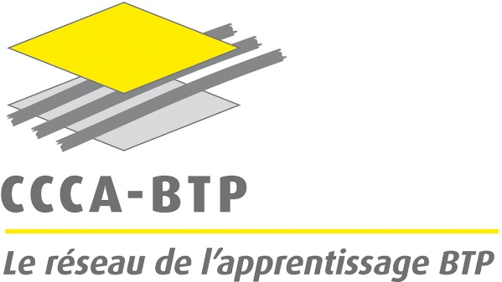

COUNTRY FEEDBACK
FRANCE

Contributors: Marek Lawinski (dir.), CCCA-BTP
Béatrice Tira, Céline Sanhaji, Nancy Arnaud Laroche & Pascal Agazzi (BTP CFA Gironde)
Philippe Dreyfus & Jérémy Eloy (BTP CFA Loire-Atlantique)

Paris, 14 June 2018

INDEX

- Information about the experimentations in France Page 3

- Results of the evaluation of the experimentations
  - Key findings Page 7
  - Answers to questions in surveys Page 10

- Conclusions for the combined evaluation model Page 32

Information about the experimentations in France

Experimentations related to Phase 4 of the ConstructyVET project were carried out within three selected training centres being a part of the CCCA-BTP network: Bordeaux-Blanquefort (2), Angers (1) and Le Mans (1). Each experimentation was prepared during a preparatory visit set up by the Training Department of the CCCA-BTP, where the following persons participated:

- ConstructyVET national manager
- Head of the training centre concerned
- Pedagogical manager
- Trainer concerned.

To guarantee a certain homogeneity to the results and to make it possible to compare them, two one-year vocational training paths were previously selected: one addressing team leaders (EQF level 4) and another one addressing worksite supervisors (EQF level 5). Within this general scheme:

- Two short modules were experienced with team leaders (the same group of trainees: in Bordeaux-Blanquefort).
- One short module was experienced with worksite supervisors (two groups of trainees: in Angers and Le Mans).

Therefore, four experimentations were carried out as follows:

Diploma concerned | Module | Duration | Participants
Professional Title Team Leader (L4) | Organisation of repetitive operations at worksite | 14 hours | 8
Professional Title Team Leader (L4) | Management and conflict resolution | 7 hours | 8
Professional Diploma Technical Manager (L5) | Cycling: Understanding, anticipating and setting up various phases at worksite - Angers | 14 hours | 12
Professional Diploma Technical Manager (L5) | Cycling: Understanding, anticipating and setting up various phases at worksite – Le Mans | 14 hours | 12
TOTAL PARTICIPANTS |  |  | 40

The diploma concerned are prepared in both: training centres and companies, under the pedagogical responsibility of the training centre, in coordination with the French coordination body: the CCCA-BTP. The full training path takes 10 months, with three weeks in company and one week in training centre each month. Each week in training centre includes up to three different training modules, learned mostly in workshops. Formal evaluation of the learning outcomes, leading to a formally recognised diploma, is organised by appropriate qualification national body, only once the whole cycle is finished. Therefore, the evaluation carried out within the framework of the ConstructyVET project could be considered only as non-formal and without any certification, given that the French Education Law imposes strict rules for every formal attribution of qualifications and certifications, in line with the requirements of National Register of Vocational Qualifications.

Experimentation 1. Organisation of repetitive operations at worksite

Title of training / name of VET track: | Part of a training path leading to Professional Title Team Leader (EQF Level 4; registered in National Register of Vocational Qualifications)
Training provider: | Vocational Education and Training Centre in the Construction Industry – Bordeaux-Blanquefort (CCCA-BTP national network)
Information about the units of learning trained: | Main objectives and contents (in line with the outcomes of the Phase 2):  - Strengthen knowledge of occupational health and safety standards.  - Know the various and complementary planning methods taking into account its different components (duration, human and other resources, orders for materials, etc.)  - Know how to build a team and assign daily work schedules for everyone with a view to a rational work organization.  - Master team coordination rules: knowing how to convey information and instructions in a clear way to be well understood, explain work sequences and manage interfaces between different stakeholders.  - Know how to control the work done by the team and to accompany the workers in the execution of the corrections.  - Strengthen the research and exploitation capacities of the tools available on the internet for information, communication and work organization purposes.
Name of document issued upon completion of the training and assessment: | Certificate of attendance.
Number of trainees: | 8
Dates of training: | 14-15 May 2018

Experimentation 2. Management and conflict resolution

Title of training / name of VET track: | Part of a training path leading to Professional Title Team Leader (EQF Level 4; registered in National Register of Vocational Qualifications)
Training provider: | Vocational Education and Training Centre in the Construction Industry – Bordeaux-Blanquefort (CCCA-BTP national network)
Information about the units of learning trained: | Main objectives and contents (in line with the outcomes of the Phase 2):  - Know how to identify your main emotions and reactions, explain them and understand them.  - Know how to identify your own emotional profile to determine your own positive aspects and those of teams and other professional partners.  - Know conflict resolution methods to better deal with conflict situations.  - Understand the relationship between emotions, stress, conflict and self-confidence.  - Be able to understand the behavioral inconsistencies of employees and be able to handle inconsistent emotional reactions.
Name of document issued upon completion of the training and assessment: | Certificate of attendance.
Number of trainees: | 8
Dates of training: | 18 May 2018

Experimentation 3. Cycling: Understanding, anticipating and setting up various phases at worksite (1)

Title of training / name of VET track: | Part of a training path leading to Professional Diploma Technical Manager (EQF Level 5; registered in National Register of Vocational Qualifications)
Training provider: | Vocational Education and Training Centre in the Construction Industry – Angers (CCCA-BTP national network)
Information about the units of learning trained: | Main objectives and contents (in line with the outcomes of the Phase 2):  - Distinguish tasks and execution phases, starting with plans and quantities.  - Estimate the duration of the work and establish the schedule.  - Master computer tools and planning software.  - Read a construction plan.  - Check insurance and applicable authorizations.  - Plan work according to priorities and emergencies.
Name of document issued upon completion of the training and assessment: | Certificate of attendance.
Number of trainees: | 12
Dates of training: | 29 May 2018

Experimentation 4. Cycling: Understanding, anticipating and setting up various phases at worksite (2)

Title of training / name of VET track: | Part of a training path leading to Professional Diploma Technical Manager (EQF Level 5; registered in National Register of Vocational Qualifications)
Training provider: | Vocational Education and Training Centre in the Construction Industry – Le Mans (CCCA-BTP national network)
Information about the units of learning trained: | Main objectives and contents (in line with the outcomes of the Phase 2):  - Distinguish tasks and execution phases, starting with plans and quantities.  - Estimate the duration of the work and establish the schedule.  - Master computer tools and planning software.  - Read a construction plan.  - Check insurance and applicable authorizations.  - Plan work according to priorities and emergencies.
Name of document issued upon completion of the training and assessment: | Certificate of attendance.
Number of trainees: | 12
Dates of training: | 1st June 2018

To date, the three first steps of evaluation were carried out (pre-training, post-training and post-assessment), given a minimum six-week period is considered as necessary between the end of questionnaire-surveys and face-to-face interviews (steps four and five). Therefore, the training centres concerned intend to carry out interviews by the end of June/ first half of July 2018. Besides, theses interviews will be combined with pedagogical guidance that the training centres concerned provide to companies participating in the training process.

The questionnaires (steps one to three) were prepared together by the Training Department of the CCCA-BTP and the Vocational Education and Training centres participating in the experimentation. The exploitation of results, carried out with the http://www.lesphinx-developpement.fr/sphinx-logiciels/logiciel-sphinx-declic/ software, was provided by the CCCA-BTP. This exploitation tool was fully appropriate to the survey as initiated following the prescriptions given by the IBE (PL), in coordination with the CCCA-BTP.

Results of the evaluation of the experimentations

Key findings

Experimentation 1. Organisation of repetitive operations at worksite (Venue: Bordeaux-Blanquefort)

Title of training / name of VET track: | Part of a training path leading to Professional Title Team Leader (EQF Level 4; registered in National Register of Vocational Qualifications)
Pre-training survey | - Questionnaire considered by trainers and trainees as easy and clear.  - Questions were understood by the participants (no requirements for clarifications).  - Satisfactory response rate (88%)  - Clear indications given to the trainer on what to stress during the training.  - Analysis of results very easy with the software chosen.  - Main topics to be developed during the training visible immediately.
Post-training survey | - Questionnaire considered by trainers and trainees as easy and clear.  - Questions were understood by the participants (no requirements for clarifications).  - Satisfactory response rate (88%)  - Clear information on what to stress during the forthcoming training.  - Analysis of results very easy with the software chosen.  - Easy comparison of results between the Pre-training and Post-training surveys.  - Thanks to the software chosen, the trainer is able to analyse the results very quickly.
Post-assessment survey | - Questionnaire considered by trainers and trainees as easy and clear.  - Questions were understood by the participants (no requirements for clarifications).  - Satisfactory response rate (100%)  - Clear information on what to stress during the future training session.  - Analysis of results very easy with the software chosen.  - Easy comparison of results between Post-training and Post-assessment survey.
Interviews with participants | Initial structure of the questionnaire evaluated positively by the head of the VET centre concerned, and especially:  - Its clarity.  - Logical chain of questions.  - Open to develop dialogue with the interviewee.  - Pragmatism in the formulation of questions.
Interviews with partners | Initial structure of the questionnaire evaluated positively by the head of the VET centre concerned, and especially:  - Its clarity.  - Logical chain of questions.  - Open to develop dialogue with the interviewee.  - Pragmatism in the formulation of questions.
Other findings | We observed a certain progressivity in the nuancing of the opinions expressed by the participants:  - Pre-training survey: objectives expressed with a lot of scores “5”  - Post-training survey: learning outcomes scored with a balance between “4” and “5”  - Post-assessment survey: objectives considered as reached scored predominantly with “4”

Experimentation 2. Management and conflict resolution

Title of training / name of VET track: | Part of a training path leading to Professional Title Team Leader (EQF Level 4; registered in National Register of Vocational Qualifications)
Pre-training survey | - Questionnaire considered by trainers and trainees as easy and clear.  - Questions were understood by the participants (no requirements for major clarifications).  - Satisfactory response rate (100%)  - Clear indications given to the trainer in terms of learning priorities.  - Analysis of results very easy with the software chosen.  - Main topics to be developed during the training visible immediately.  - Clear indication of the topics considered by the participants as secondary.
Post-training survey | - Questionnaire considered by trainers and trainees as easy and clear.  - Questions were understood by the participants (no requirements for clarifications).  - Satisfactory response rate (100%)  - Clear information on what to stress during the forthcoming training.  - Analysis of results very easy with the software chosen.  - Easy comparison of results between the Pre-training and Post-training surveys.  - Thanks to the software chosen, the trainer is able to analyse the results very quickly.  - Positive points underlined by the participants and by the trainer:  - Evaluation made it possible to evaluate both training contents and methods used,  - Priorities to be chosen during next similar sessions clarified.
Post-assessment survey | - Questionnaire always considered by trainers and trainees as easy and clear as the two previous ones.  - Satisfactory response rate (100%)  - Clear information on what to develop and strengthen during the future training session.  - Analysis of results quite easy with the software chosen.  - Fast comparison of results between Post-training and Post-assessment survey.
Interviews with participants | Initial structure of the questionnaire evaluated positively by the pedagogical management of the VET centre concerned, and especially:  - Its clarity was highlighted.  - Logical chain of questions (providing qualitative and quantitative information) was pointed out.  - Open to develop dialogue with the interviewee.  - Pragmatism and synthesis in the formulation of questions.
Interviews with partners | Initial structure of the questionnaire evaluated positively by the pedagogical management of the VET centre concerned, and especially:  - Its clarity was highlighted.  - Logical chain of questions (providing qualitative and quantitative information) was pointed out.  - Open to develop dialogue with the interviewee.  - Pragmatism and synthesis in the formulation of questions.  - Good opportunity to reinforce contacts with companies where trainees are from.
Other findings | The progressivity in the nuancing of the opinions expressed by the participants:  - Pre-training survey: objectives expressed with a lot of scores “5”  - Post-training survey: learning outcomes scored with a balance between “4” and “5”  - Post-assessment survey: objectives considered as reached scored predominantly with “3” and “4”

Experimentations 3 & 4 gave quite similar results, which demonstrates a significant synergy of approaches, whatever the modules, publics and venues. On the whole, the questionnaires 1, 2 & 3 correspond to the initial objectives and made it possible, within the French context, the combined evaluation of:

- Initial expectations expressed by learners.
- Learning outcomes immediately after the training module, together with the assessment of methods and learning conditions.
- Usefulness of the learning outcomes within concrete work situations in companies.

Parallel to this, the questionnaires tested in the Phase 4 of the project demonstrated that it was possible to use them for any kind of modules: organisational-technical (experimentations 1, 3 & 4) and more typically managerial (experimentation 2).

Answers to questions in surveys

Below, you will find the detailed results of the experimentations 1 & 2, considered as the most significant within the French context. The purpose is to identify the most significant differences in the evaluation of two different types of learning modules addressing worksite supervisors:

- Module 1: Organisation of repetitive operations at worksite (organisational-technical)
- Module 2: Management and conflict resolution (managerial).

Both modules remain fully in line with the conclusion of the Phase 2 ConstructyVET project in terms of objectives, contents and assessment criteria. Nevertheless, to take into account the specificity of the French target group and its individual objectives, the Training Department of the CCCA-BTP, together with the training centres concerned, fulfilled a preliminary work consisting of:

- Analysis of the common modules and contents identified within the project Phase 2 and reinforced with relevant methodological guidelines further to the project Phase 3.
- Identification of objectives, contents and assessment criteria corresponding to the modules to be set up in the French training centres, according to specific profiles of the learners identified for the experimental actions.
- Full-scale test of the objectives and contents specified, together with the experimentation of the three questionnaires related to each training session.

Results of the Experimentation 1. Organisation of repetitive operations at worksite (Venue: Bordeaux-Blanquefort)

Pre-training survey

Age
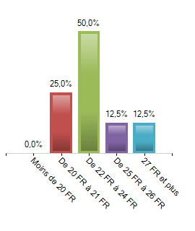
 | Population | % Answers
- 20 years old | 0 | 0%
20 - 21 years old | 2 | 25%
22 - 24 years old | 4 | 50%
25 - 26 years old | 1 | 12,5%
27 years old + | 1 | 12,5%
Total | 8 | 100%
Total Answers: 8 | No answer(s): 1
Answer Rate: 88,9% | Average: 22.88  Min - Max : 20 - 27

Gender
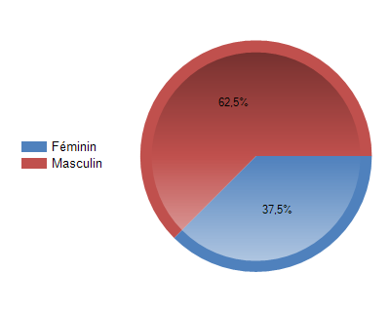
 | Population | % Answers
Female | 3 | 37,5%
Male | 5 | 62,5%
Total | 8 | 100%

Total Anwers: 8 | No answer(s): 1
Answer Rate : 88,9% | Modality the most listed: Male

Why do you participate in the training? (Multiple choice)

 | Population | % Answers
I need the skills – it will be useful for work | 6 | 75%
I like to learn new things / out of curiosity | 6 | 75%
My employer sent me / it was obligatory | 0 | 0%
Other | 0 | 0%
Total | 8

Total Anwers: 8 | No answer(s): 1
Answer Rate : 88,9% | Modality the most listed: I need the skills – it will be useful for work
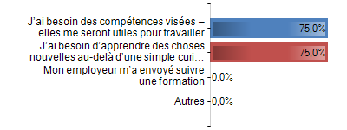

What do you expect from the training?

OUTCOMES
 | Population | % Answers
I need the skills – it will be useful for work | 7 | 87,5%
Long term effect on job position | 5 | 62,5%
Better understanding of the field | 3 | 37,5%
Learning how to solve typical problems | 3 | 37,5%
Other | 1 | 12,5%
Total | 8

Total Anwers: 8 | No answer(s): 1
Answer Rate : 88,9% | Modality the most listed: I need the skills – it will be useful for work
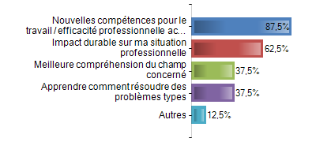

FORMS
 | Population | % Answers
Lectures / presentations | 5 | 62,5%
Practical training / simulation | 7 | 87,5%
Group work | 3 | 37,5%
Other: _____________ | 1 | 12,5%
Total | 8

Total Anwers: 8 | No answer(s): 1
Answer Rate : 88,9% | Modality the most listed: Practical training / simulation

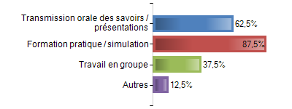

What is the most significant competence you expect from the training?

- Capacity for analyzing activities
- Know how to lead, organize, have a good orientation of the work that we will have to do in the future
- To know better how to express myself with respect to my collaborators
- Organize and manage a team
- Organization, planning, management time / quantity manpower
- Have a good management degree in a team
- All that is planning, management of a team
- Planning and managing a team - know-how

Self-assessment. Would you meet the following requirements?

 | 1 |  | 2 |  | 3 |  | 4 |  | 5 |  | Total
 | Nb. | %. | Nb. | %. | Nb. | % | Nb. | % | Nb. | % | Nb. | %
Strengthen knowledge of occupational health and safety standards. | 0 | 0% | 0 | 0% | 3 | 37,5% | 3 | 37,5% | 2 | 25% | 8 | 100%
Know the various and complementary planning methods taking into account its different components (duration, human and other resources, orders for materials, etc.) | 0 | 0% | 1 | 12,5% | 1 | 12,5% | 1 | 12,5% | 5 | 62,5% | 8 | 100%
Know how to build a team and assign daily work schedules for everyone with a view to a rational work organization. | 0 | 0% | 0 | 0% | 0 | 0% | 1 | 12,5% | 7 | 87,5% | 8 | 100%
Master team coordination rules: knowing how to convey information and instructions in a clear way to be well understood, explain work sequences and manage interfaces between different stakeholders. | 0 | 0% | 0 | 0% | 2 | 25% | 0 | 0% | 6 | 75% | 8 | 100%
Know how to control the work done by the team and to accompany the workers in the execution of the corrections. | 0 | 0% | 0 | 0% | 1 | 12,5% | 1 | 12,5% | 6 | 75% | 8 | 100%
Strengthen the research and exploitation capacities of the tools available on the internet for information, communication and work organization purposes. | 0 | 0% | 0 | 0% | 3 | 37,5% | 3 | 37,5% | 2 | 25% | 8 | 100%
Total | 0 | 0% | 1 | 2,1% | 10 | 20,8% | 9 | 18,8% | 28 | 58,3% | 48 | 100%

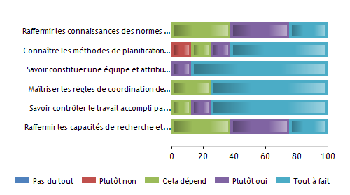

Post-training survey

Age
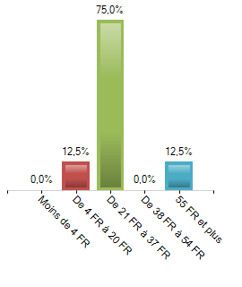
 | Population | % Answers
- 18 years old | 0 | 0%
18 - 20 years old | 1 | 12,5%
21 - 23 years old | 6 | 75%
24 - 26 years old | 0 | 0%
27 years old + | 1 | 12,5%
Total | 8 | 100%
Total Answers: 8 | No answer(s): 1
Answer Rate: 88,9% | Average: 22  Min - Max : 17 - 27

Gender
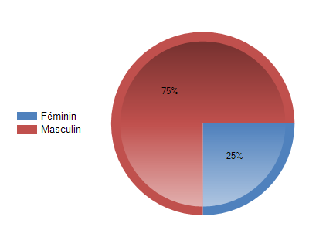
 | Population | % Answers
Female | 2 | 25%
Male | 6 | 75%
Total | 8 | 100%

Total Anwers: 8 | No answer(s): 1
Answer Rate : 88,9% | Modality the most listed: Male

General feedback

 | 1 |  | 2 |  | 3 |  | 4 |  | 5 |  | Total
 | Nb. | %. | Nb. | %. | Nb. | % | Nb. | % | Nb. | % | Nb. | %
Overall Verdict | 0 | 0% | 0 | 0% | 2 | 25% | 5 | 62,5% | 1 | 12,5% | 8 | 100%
Training Structure | 0 | 0% | 0 | 0% | 1 | 12,5% | 6 | 75% | 1 | 12,5% | 8 | 100%
Training Content | 0 | 0% | 0 | 0% | 1 | 12,5% | 3 | 37,5% | 4 | 50% | 8 | 100%
Theory was supported by practice | 0 | 0% | 0 | 0% | 2 | 25% | 5 | 62,5% | 1 | 12,5% | 8 | 100%
Trainer(s) | 0 | 0% | 0 | 0% | 1 | 12,5% | 3 | 37,5% | 4 | 50% | 8 | 100%
Venue | 0 | 0% | 1 | 12,5% | 3 | 37,5% | 3 | 37,5% | 1 | 12,5% | 8 | 100%
Pace of Training | 0 | 0% | 0 | 0% | 2 | 25% | 5 | 62,5% | 1 | 12,5% | 8 | 100%
I had fun | 0 | 0% | 0 | 0% | 1 | 12,5% | 4 | 50% | 3 | 37,5% | 8 | 100%
I learnt something useful | 0 | 0% | 0 | 0% | 0 | 0% | 5 | 62,5% | 3 | 37,5% | 8 | 100%
I am glad I came | 0 | 0% | 0 | 0% | 1 | 12,5% | 4 | 50% | 3 | 37,5% | 8 | 100%
Training vs. expectations | 0 | 0% | 0 | 0% | 2 | 25% | 4 | 50% | 2 | 25% | 8 | 100%
Total | 0 | 0% | 1 | 1,1% | 16 | 18,2% | 47 | 53,4% | 24 | 27,3% | 88 | 100%

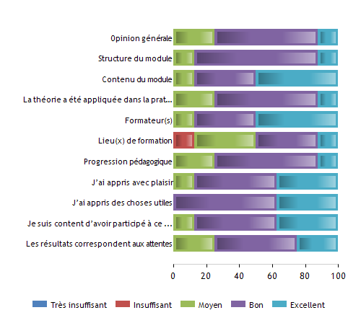
Did the training help you in the developing of the following competences?

 | 1 |  | 2 |  | 3 |  | 4 |  | 5 |  | Total
 | Nb. | %. | Nb. | %. | Nb. | % | Nb. | % | Nb. | % | Nb. | %
Strengthen knowledge of occupational health and safety standards. | 0 | 0% | 0 | 0% | 4 | 50% | 3 | 37,5% | 1 | 12,5% | 8 | 100%
Know the various and complementary planning methods taking into account its different components (duration, human and other resources, orders for materials, etc.) | 0 | 0% | 0 | 0% | 2 | 25% | 3 | 37,5% | 3 | 37,5% | 8 | 100%
Know how to build a team and assign daily work schedules for everyone with a view to a rational work organization. | 0 | 0% | 0 | 0% | 1 | 12,5% | 4 | 50% | 3 | 37,5% | 8 | 100%
Master team coordination rules: knowing how to convey information and instructions in a clear way to be well understood, explain work sequences and manage interfaces between different stakeholders. | 0 | 0% | 0 | 0% | 2 | 25% | 2 | 25% | 4 | 50% | 8 | 100%
Know how to control the work done by the team and to accompany the workers in the execution of the corrections. | 0 | 0% | 0 | 0% | 1 | 12,5% | 5 | 62,5% | 2 | 25% | 8 | 100%
Strengthen the research and exploitation capacities of the tools available on the internet for information, communication and work organization purposes. | 0 | 0% | 0 | 0% | 2 | 25% | 4 | 50% | 2 | 25% | 8 | 100%
Total | 0 | 0% | 0 | 0% | 12 | 25% | 21 | 43,8% | 15 | 31,2% | 48 | 100%
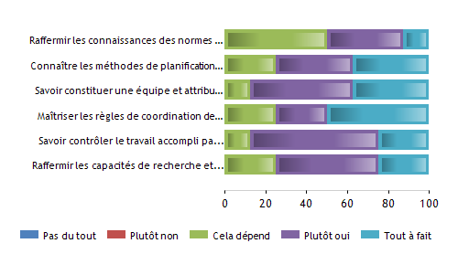

Which outcomes do you think will be useful for your work?

 | 1 |  |  |  | 2 |  |  |  | 3 |  |  |  | 4 |  |  |  | 5 |  |  |  | Total
 | Nb. |  | %. |  | Nb. |  | %. |  | Nb. |  | % |  | Nb. |  | % |  | Nb. |  | % |  | Nb. |  | %
Knowledge of occupational health and safety standards. | 0 | 0% |  | 0 |  | 0% |  | 4 |  | 50% |  | 3 |  | 37,5% |  | 1 |  | 12,5% |  | 8 |  | 100%
Various and complementary planning methods taking into account its different components (duration, human and other resources, orders for materials, etc.) | 0 | 0% |  | 0 |  | 0% |  | 1 |  | 12,5% |  | 4 |  | 50% |  | 3 |  | 37,5% |  | 8 |  | 100%
Ability to build a team and assign daily work schedules for everyone in the interest of a rational work organization. | 0 | 0% |  | 0 |  | 0% |  | 1 |  | 12,5% |  | 4 |  | 50% |  | 3 |  | 37,5% |  | 8 |  | 100%
Team coordination rules: convey information and instructions in a clear manner to be understood, explain work sequences and manage interfaces between different stakeholders. | 0 | 0% |  | 0 |  | 0% |  | 2 |  | 25% |  | 3 |  | 37,5% |  | 3 |  | 37,5% |  | 8 |  | 100%
Control the work done by the team and accompany the workers in the execution of corrections if necessary. | 0 | 0% |  | 0 |  | 0% |  | 1 |  | 12,5% |  | 6 |  | 75% |  | 1 |  | 12,5% |  | 8 |  | 100%
Research and exploitation capabilities of the tools available on the internet for information, communication and work organization purposes. | 0 | 0% |  | 0 |  | 0% |  | 2 |  | 25% |  | 5 |  | 62,5% |  | 1 |  | 12,5% |  | 8 |  | 100%
Total | 0 | 0% |  | 0 |  | 0% |  | 11 |  | 22,9% |  | 25 |  | 52,1% |  | 12 |  | 25% |  | 48 |  | 100%
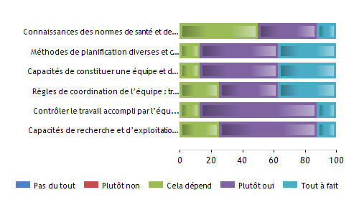

What else/next would like to learn?
- 3 answers "I do not know"
- "Documents in color especially for painters"

Which teaching/learning forms did the training consist of?

 | Yes |  | No |  | Total
 | Nb. | % | Nb. | % | Nb. | %
Lecture / presentation; | 8 | 100% | 0 | 0% | 8
Practical training / simulation; | 8 | 100% | 0 | 0% | 8
Group work; | 5 | 62,5% | 3 | 37,5% | 8
Research on Internet | 7 | 87,5% | 1 | 12,5% | 8
Self-learning | 4 | 50% | 4 | 50% | 8
Total | 32 | 80% | 8 | 20% | 40

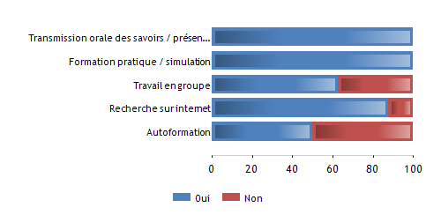

To what extent do you agree with the following statements?

 | 1 |  | 2 |  | 3 |  | 4 |  | 5 |  | Total
 | Nb. | % | Nb. | % | Nb. | % | Nb. | % | Nb. | % | Nb. | %
The goals of the training were clearly defined | 0 | 0% | 0 | 0% | 1 | 12,5% | 2 | 25% | 5 | 62,5% | 8 | 100%
The covered topics were relevant to course | 0 | 0% | 0 | 0% | 1 | 12,5% | 2 | 25% | 5 | 62,5% | 8 | 100%
Training materials were well prepared | 0 | 0% | 0 | 0% | 2 | 25% | 2 | 25% | 4 | 50% | 8 | 100%
Methods of training were relevant for the training goals | 0 | 0% | 1 | 12,5% | 1 | 12,5% | 2 | 25% | 4 | 50% | 8 | 100%
The training time was just right | 0 | 0% | 0 | 0% | 0 | 0% | 4 | 50% | 4 | 50% | 8 | 100%
The course content was simple and understandable | 0 | 0% | 1 | 12,5% | 1 | 12,5% | 2 | 25% | 4 | 50% | 8 | 100%
The trainer actively involved me in the process | 0 | 0% | 0 | 0% | 1 | 12,5% | 2 | 25% | 5 | 62,5% | 8 | 100%
Total | 0 | 0% | 2 | 3,6% | 7 | 12,5% | 16 | 28,6% | 31 | 55,4% | 56 | 100%
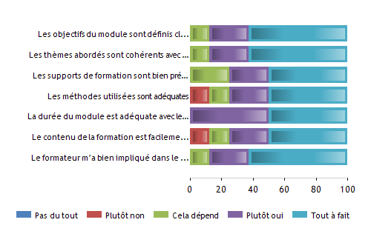

What could be improved / changed?
      - 2 answers "I do not know"
      - "Start Monday at 8:15 instead of 9am"

Post-assessment survey

Age
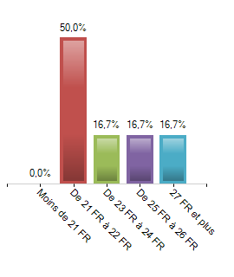
 | Population | % Answers
- 21 years old | 0 | 0%
21 - 22 years old | 3 | 50%
23 - 24 years old | 1 | 16,7%
25 - 26 years old | 1 | 16,7%
27 years old + | 1 | 16,7%
Total | 6 | 100%

Total Answers: 6 | No answer(s): 0
Answer Rate: 100% | Average: 23.5  Min - Max : 21-27

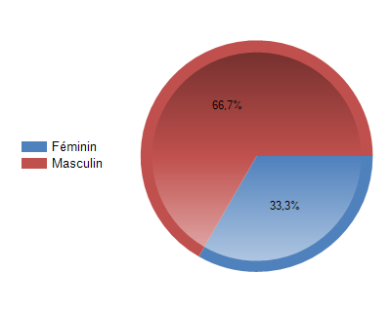
Gender

 | Population | % Answers
Female | 2 | 33,3%
Male | 4 | 66,7%
Total | 6 | 100%

Total Anwers: 6 | No answer(s): 0
Answer Rate : 100% | Modality the most listed: Male

Self-assessment. Have you achieved the following learning outcomes?

 | 1 |  | 2 |  | 3 |  | 4 |  | 5 |  | Total
 | Nb. | % | Nb. | % | Nb. | % | Nb. | % | Nb. | % | Nb. | %
Strengthen knowledge of occupational health and safety standards. | 0 | 0% | 1 | 16,7% | 2 | 33,3% | 3 | 50% | 0 | 0% | 6 | 100%
Know the various and complementary planning methods taking into account its different components (duration, human and other resources, orders for materials, etc.) | 0 | 0% | 0 | 0% | 0 | 0% | 5 | 83,3% | 1 | 16,7% | 6 | 100%
Know how to build a team and assign daily work schedules for everyone with a view to a rational work organization. | 0 | 0% | 0 | 0% | 0 | 0% | 5 | 83,3% | 1 | 16,7% | 6 | 100%
Master team coordination rules: knowing how to convey information and instructions in a clear way to be well understood, explain work sequences and manage interfaces between different stakeholders. | 0 | 0% | 0 | 0% | 0 | 0% | 5 | 83,3% | 1 | 16,7% | 6 | 100%
Know how to control the work done by the team and to accompany the workers in the execution of the corrections. | 0 | 0% | 0 | 0% | 0 | 0% | 5 | 83,3% | 1 | 16,7% | 6 | 100%
Strengthen the research and exploitation capacities of the tools available on the internet for information, communication and work organization purposes. | 0 | 0% | 0 | 0% | 2 | 33,3% | 3 | 50% | 1 | 16,7% | 6 | 100%
Total | 0 | 0% | 1 | 2,8% | 4 | 11,1% | 26 | 72,2% | 5 | 13,9% | 36 | 100%
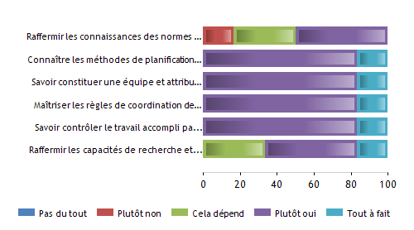

Did the knowledge / skills learned in this module help you in your work?

 | 1 |  | 2 |  | 3 |  | 4 |  | 5 |  | Total
 | Nb. | % | Nb. | % | Nb. | % | Nb. | % | Nb. | % | Nb. | %
Knowledge of occupational health and safety standards. | 0 | 0% | 0 | 0% | 1 | 16,7% | 4 | 66,7% | 1 | 16,7% | 6 | 100%
Various and complementary planning methods taking into account its different components (duration, human and other resources, orders for materials, etc.) | 0 | 0% | 0 | 0% | 0 | 0% | 6 | 100% | 0 | 0% | 6 | 100%
Ability to build a team and assign daily work schedules for everyone in the interest of a rational work organization. | 0 | 0% | 0 | 0% | 0 | 0% | 6 | 100% | 0 | 0% | 6 | 100%
Team coordination rules: convey information and instructions in a clear manner to be understood, explain work sequences and manage interfaces between different stakeholders. | 0 | 0% | 0 | 0% | 2 | 33,3% | 4 | 66,7% | 0 | 0% | 6 | 100%
Control the work done by the team and accompany the workers in the execution of corrections if necessary. | 0 | 0% | 0 | 0% | 0 | 0% | 6 | 100% | 0 | 0% | 6 | 100%
Research and exploitation capabilities of the tools available on the internet for information, communication and work organization purposes. | 0 | 0% | 0 | 0% | 2 | 33,3% | 4 | 66,7% | 0 | 0% | 6 | 100%
Total | 0 | 0% | 0 | 0% | 5 | 13,9% | 30 | 83,3% | 1 | 2,8% | 36 | 100%

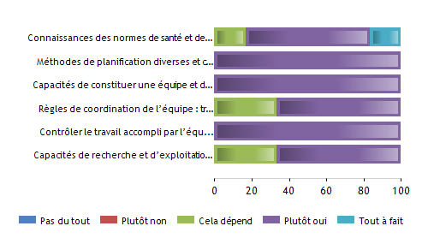

Results of the Experimentation 2. Management and conflict resolution

Pre-training survey

Age
 | Population | % Answers
- 20 years old | 0 | 0%
20 - 21 years old | 2 | 25%
22 - 24 years old | 4 | 50%
25 - 26 years old | 1 | 12,5%
27 years old + | 1 | 12,5%
Total | 8 | 100%
Total Answers: 8 | No answer(s): 0
Answer Rate: 100% | Average: 22.88  Min - Max : 20 - 27

Gender

 | Population | % Answers
Female | 2 | 25%
Male | 6 | 75%
Total | 8 | 100%

Total Anwers: 8 | No answer(s): 0
Answer Rate : 100% | Modality the most listed: Male

Why do you participate in the training? (Multiple choice)

 | Population | % Answers
I need the skills – it will be useful for work | 8 | 100%
I like to learn new things / out of curiosity | 6 | 75%
My employer sent me / it was obligatory | 0 | 0%
Other | 0 | 0%
Total | 8

Total Anwers: 8 | No answer(s): 0
Answer Rate : 100% | Modality the most listed: I need the skills – it will be useful for work

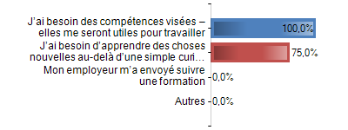
What do you expect from the training?

OUTCOMES
 | Population | % Answers
I need the skills – it will be useful for work | 6 | 75%
Long term effect on job position | 5 | 62,5%
Better understanding of the field | 4 | 50%
Learning how to solve typical problems | 4 | 50%
Other | 0 | 0%
Total | 8

Total Anwers: 8 | No answer(s): 0
Answer Rate : 100% | Modality the most listed: I need the skills – it will be useful for work
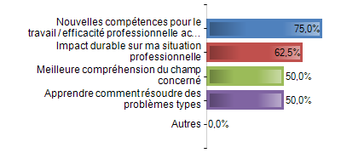

FORMS
 | Population | % Answers
Lectures / presentations | 7 | 87,5%
Practical training / simulation | 5 | 62,5%
Group work | 6 | 75%
Other: _____________ | 1 | 12,5%
Total | 8

Total Anwers: 8 | No answer(s): 1
Answer Rate : 88,9% | Modality the most listed: Practical training / simulation

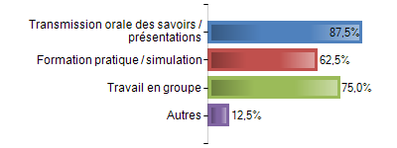

What is the most significant competence you expect from the training?

      - Group work and dialogue
      - Adapt your speech to the audience
      - Have a better communication with my team
      - To be able to manage a team in the best conditions

Self-assessment. Would you meet the following requirements?

 | 1 |  | 2 |  | 3 |  | 4 |  | 5 |  | Total
 | Nb. | %. | Nb. | %. | Nb. | % | Nb. | % | Nb. | % | Nb. | %
Know how to identify your main emotions and reactions, explain them and understand them. | 0 | 0% | 1 | 12,5% | 2 | 25% | 1 | 12,5% | 4 | 50% | 8 | 100%
Know how to identify your own emotional profile to determine your own positive aspects and those of teams and other professional partners. | 0 | 0% | 1 | 12,5% | 3 | 37,5% | 0 | 0% | 4 | 50% | 8 | 100%
Know conflict resolution methods to better deal with conflict situations. | 0 | 0% | 1 | 12,5% | 2 | 25% | 1 | 12,5% | 4 | 50% | 8 | 100%
Understand the relationship between emotions, stress, conflict and self-confidence | 0 | 0% | 1 | 12,5% | 2 | 25% | 1 | 12,5% | 4 | 50% | 8 | 100%
Be able to understand the behavioral inconsistencies of employees and be able to handle inconsistent emotional reactions. | 0 | 0% | 0 | 0% | 3 | 37,5% | 1 | 12,5% | 4 | 50% | 8 | 100%
Total | 0 | 0% | 4 | 10% | 12 | 30% | 4 | 10% | 20 | 50% | 40 | 100%
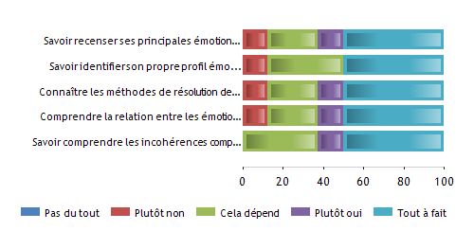

Post-training survey

Age
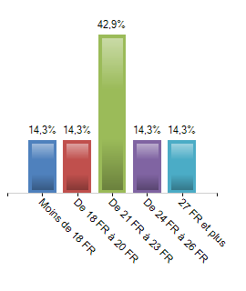
 | Population | % Answers
- 18 years old | 1 | 14,3%
18 - 20 years old | 1 | 14,3%
21 - 23 years old | 3 | 42,9%
24 - 26 years old | 1 | 14,3%
27 years old + | 1 | 14,3%
Total | 7 | 100%
Total Answers: 7 | No answer(s): 0
Answer Rate: 100% | Average: 22.14  Min - Max : 17 - 27
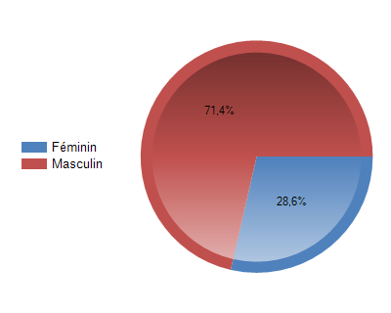
Gender

 | Population | % Answers
Female | 2 | 28,6%
Male | 5 | 71,4%
Total | 7 | 100%

Total Anwers: 7 | No answer(s): 0
Answer Rate : 100% | Modality the most listed: Male

General feedback

 | 1 |  | 2 |  | 3 |  | 4 |  | 5 |  | Total
 | Nb. | %. | Nb. | %. | Nb. | % | Nb. | % | Nb. | % | Nb. | %
Overall Verdict | 0 | 0% | 1 | 14,3% | 1 | 14,3% | 4 | 57,1% | 1 | 14,3% | 7 | 100%
Training Structure | 0 | 0% | 0 | 0% | 3 | 42,9% | 3 | 42,9% | 1 | 14,3% | 7 | 100%
Training Content | 0 | 0% | 1 | 14,3% | 1 | 14,3% | 5 | 71,4% | 0 | 0% | 7 | 100%
Theory was supported by practice | 0 | 0% | 0 | 0% | 2 | 28,6% | 4 | 57,1% | 1 | 14,3% | 7 | 100%
Trainer(s) | 0 | 0% | 0 | 0% | 2 | 28,6% | 4 | 57,1% | 1 | 14,3% | 7 | 100%
Venue | 0 | 0% | 1 | 14,3% | 3 | 42,9% | 3 | 42,9% | 0 | 0% | 7 | 100%
Pace of Training | 0 | 0% | 0 | 0% | 1 | 14,3% | 5 | 71,4% | 1 | 14,3% | 7 | 100%
I had fun | 0 | 0% | 0 | 0% | 1 | 14,3% | 5 | 71,4% | 1 | 14,3% | 7 | 100%
I learnt something useful | 0 | 0% | 0 | 0% | 1 | 16,7% | 2 | 33,3% | 3 | 50% | 6 | 100%
I am glad I came | 0 | 0% | 0 | 0% | 1 | 16,7% | 3 | 50% | 2 | 33,3% | 6 | 100%
Training vs. expectations | 0 | 0% | 0 | 0% | 1 | 16,7% | 4 | 66,7% | 1 | 16,7% | 6 | 100%
Total | 0 | 0% | 3 | 4,1% | 17 | 23% | 42 | 56,8% | 12 | 16,2% | 74 | 100%

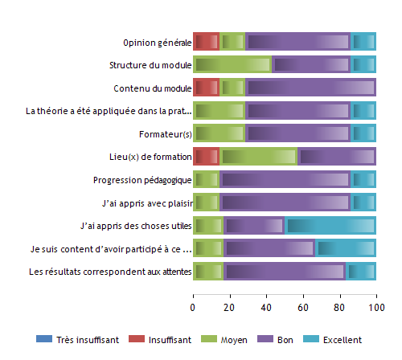

Did the training help you in the developing of the following competences?

 | 1 |  | 2 |  | 3 |  | 4 |  | 5 |  | Total
 | Nb. | %. | Nb. | %. | Nb. | % | Nb. | % | Nb. | % | Nb. | %
Know how to identify your main emotions and reactions, explain them and understand them. | 0 | 0% | 1 | 14,3% | 3 | 42,9% | 3 | 42,9% | 0 | 0% | 7 | 100%
Know how to identify your own emotional profile to determine your own positive aspects and those of teams and other professional partners. | 0 | 0% | 1 | 14,3% | 1 | 14,3% | 5 | 71,4% | 0 | 0% | 7 | 100%
Know conflict resolution methods to better deal with conflict situations. | 0 | 0% | 0 | 0% | 2 | 28,6% | 4 | 57,1% | 1 | 14,3% | 7 | 100%
Understand the relationship between emotions, stress, conflict and self-confidence | 0 | 0% | 0 | 0% | 1 | 14,3% | 5 | 71,4% | 1 | 14,3% | 7 | 100%
Be able to understand the behavioral inconsistencies of employees and be able to handle inconsistent emotional reactions. | 0 | 0% | 0 | 0% | 2 | 28,6% | 5 | 71,4% | 0 | 0% | 7 | 100%
Total | 0 | 0% | 2 | 5,7% | 9 | 25,7% | 22 | 62,9% | 2 | 5,7% | 35 | 100%
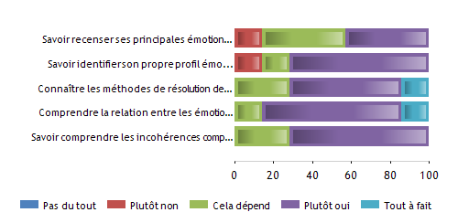

Which outcomes do you think will be useful for your work?

 | 1 |  |  |  | 2 |  |  |  | 3 |  |  |  | 4 |  |  |  | 5 |  |  |  | Total
 | Nb. |  | %. |  | Nb. |  | %. |  | Nb. |  | % |  | Nb. |  | % |  | Nb. |  | % |  | Nb. |  | %
Ability to identify and explain and understand key emotions and reactions. | 0 | 0% |  | 0 |  | 0% |  | 1 |  | 16,7% |  | 5 |  | 83,3% |  | 0 |  | 0% |  | 6 |  | 100%
Ability to identify one's own emotional profile to determine one's own positive aspects and those of teams and other professional partners. | 0 | 0% |  | 0 |  | 0% |  | 1 |  | 16,7% |  | 4 |  | 66,7% |  | 1 |  | 16,7% |  | 6 |  | 100%
Knowledge of conflict resolution methods to better deal with conflict situations. | 0 | 0% |  | 0 |  | 0% |  | 2 |  | 33,3% |  | 4 |  | 66,7% |  | 0 |  | 0% |  | 6 |  | 100%
Understanding the relationship between emotions, stress, conflict and self-confidence. | 0 | 0% |  | 0 |  | 0% |  | 2 |  | 33,3% |  | 4 |  | 66,7% |  | 0 |  | 0% |  | 6 |  | 100%
Understand behavioral inconsistencies of employees to be able to handle inconsistent emotional reactions. | 0 | 0% |  | 0 |  | 0% |  | 2 |  | 28,6% |  | 4 |  | 57,1% |  | 1 |  | 14,3% |  | 7 |  | 100%
Total | 0 | 0% |  | 0 |  | 0% |  | 8 |  | 25,8% |  | 21 |  | 67,7% |  | 2 |  | 6,5% |  | 31 |  | 100%
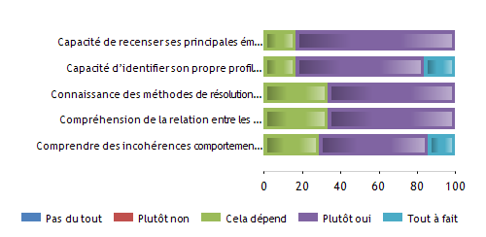

What else/next would like to learn?
1 answer: "More scenarios even if there are already a lot of them"

Which teaching/learning forms did the training consist of?

 | Yes |  | No |  | Total
 | Nb. | % | Nb. | % | Nb. | %
Lecture / presentation; | 7 | 100% | 0 | 0% | 7
Practical training / simulation; | 5 | 71,4% | 2 | 28,6% | 7
Group work; | 5 | 71,4% | 2 | 28,6% | 7
Research on Internet | 2 | 28,6% | 5 | 71,4% | 7
Self-learning | 5 | 71,4% | 2 | 28,6% | 7
Total | 24 | 68,6% | 11 | 31,4% | 35

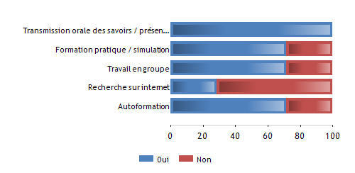

To what extent do you agree with the following statements?

 | 1 |  | 2 |  | 3 |  | 4 |  | 5 |  | Total
 | Nb. | % | Nb. | % | Nb. | % | Nb. | % | Nb. | % | Nb. | %
The goals of the training were clearly defined | 0 | 0% | 0 | 0% | 2 | 28,6% | 3 | 42,9% | 2 | 28,6% | 7 | 100%
The covered topics were relevant to course | 0 | 0% | 0 | 0% | 2 | 33,3% | 2 | 33,3% | 2 | 33,3% | 6 | 100%
Training materials were well prepared | 0 | 0% | 0 | 0% | 1 | 16,7% | 2 | 33,3% | 3 | 50% | 6 | 100%
Methods of training were relevant for the training goals | 0 | 0% | 0 | 0% | 2 | 33,3% | 3 | 50% | 1 | 16,7% | 6 | 100%
The training time was just right | 0 | 0% | 1 | 16,7% | 1 | 16,7% | 3 | 50% | 1 | 16,7% | 6 | 100%
The course content was simple and understandable | 0 | 0% | 0 | 0% | 2 | 33,3% | 2 | 33,3% | 2 | 33,3% | 6 | 100%
The trainer actively involved me in the process | 0 | 0% | 0 | 0% | 1 | 16,7% | 3 | 50% | 2 | 33,3% | 6 | 100%
Total | 0 | 0% | 1 | 2,3% | 11 | 25,6% | 18 | 41,9% | 13 | 30,2% | 43 | 100%
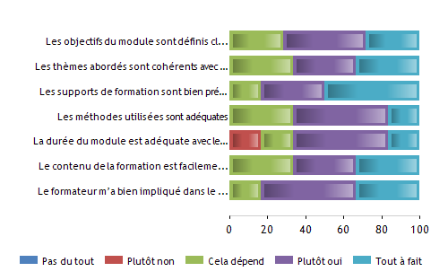

What could be improved / changed?
      - "Less paper, more digital"
      - "Be more dynamic"

Post-assessment survey

Age
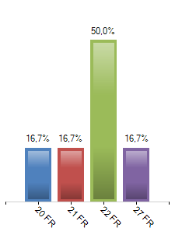
 | Population | % Answers
20 years old | 1 | 16,7%
21 years old | 1 | 16,7%
22 years old | 3 | 50%
27 years old | 1 | 16,7%
Total | 6 | 100%
Total Answers: 6 | No answer(s): 0
Answer Rate: 100% | Average: 23.5  Min - Max : 20-27
Gender

 | Population | % Answers
Female | 2 | 33,3%
Male | 4 | 66,7%
Total | 6 | 100%

Total Anwers: 6 | No answer(s): 0
Answer Rate : 100% | Modality the most listed: Male

Self-assessment. Have you achieved the following learning outcomes?

 | 1 |  | 2 |  | 3 |  | 4 |  | 5 |  | Total
 | Nb. | % | Nb. | % | Nb. | % | Nb. | % | Nb. | % | Nb. | %
Know how to identify your main emotions and reactions, explain them and understand them. | 0 | 0% | 1 | 16,7% | 2 | 33,3% | 2 | 33,3% | 1 | 16,7% | 6 | 100%
Know how to identify your own emotional profile to determine your own positive aspects and those of teams and other professional partners. | 0 | 0% | 0 | 0% | 4 | 66,7% | 1 | 16,7% | 1 | 16,7% | 6 | 100%
Know conflict resolution methods to better deal with conflict situations. | 0 | 0% | 0 | 0% | 2 | 33,3% | 3 | 50% | 1 | 16,7% | 6 | 100%
Understand the relationship between emotions, stress, conflict and self-confidence | 0 | 0% | 0 | 0% | 3 | 50% | 2 | 33,3% | 1 | 16,7% | 6 | 100%
Be able to understand the behavioral inconsistencies of employees and be able to handle inconsistent emotional reactions. | 0 | 0% | 0 | 0% | 3 | 50% | 2 | 33,3% | 1 | 16,7% | 6 | 100%
Total | 0 | 0% | 1 | 3,3% | 14 | 46,7% | 10 | 33,3% | 5 | 16,7% | 30 | 100%
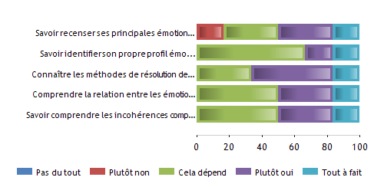

Did the knowledge / skills learned in this module help you in your work?

 | 1 |  | 2 |  | 3 |  | 4 |  | 5 |  | Total
 | Nb. | % | Nb. | % | Nb. | % | Nb. | % | Nb. | % | Nb. | %
Ability to identify and explain and understand key emotions and reactions. | 0 | 0% | 0 | 0% | 2 | 33,3% | 3 | 50% | 1 | 16,7% | 6 | 100%
Ability to identify one's own emotional profile to determine one's own positive aspects and those of teams and other professional partners. | 0 | 0% | 0 | 0% | 3 | 50% | 2 | 33,3% | 1 | 16,7% | 6 | 100%
Knowledge of conflict resolution methods to better deal with conflict situations. | 0 | 0% | 0 | 0% | 3 | 50% | 2 | 33,3% | 1 | 16,7% | 6 | 100%
Understanding the relationship between emotions, stress, conflict and self-confidence. | 0 | 0% | 0 | 0% | 3 | 50% | 2 | 33,3% | 1 | 16,7% | 6 | 100%
Understand behavioral inconsistencies of employees to be able to handle inconsistent emotional reactions. | 0 | 0% | 0 | 0% | 3 | 50% | 2 | 33,3% | 1 | 16,7% | 6 | 100%
Total | 0 | 0% | 0 | 0% | 14 | 46,7% | 11 | 36,7% | 5 | 16,7% | 30 | 100%

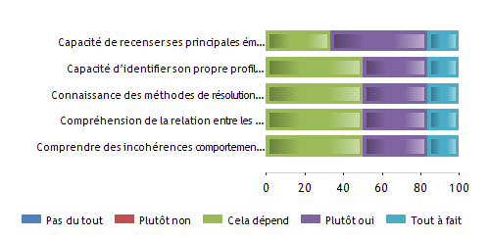

What could be changed / improved?
      - One answer: "Everything was perfect"

Conclusions for the combined evaluation model

The proposed common model for combined evaluations was adjusted to the specificities observed within the French context taking into account the following aspects:

      - Modules chosen as a part of more consistent training paths of vocational initial education addressing team leaders (EQF level 4) and worksite supervisors (EQF level 5).
      - Relative homogeneity of the groups of learners chosen (all rather young and in initial training).
      - Modules being a part of larger training organised as a 10-month apprenticeship, with the following rhythm each month:
- One week in training centre for technological and practical training (in classrooms and workshops).
- Three weeks in company with operational responsibilities (opportunities for simultaneous learning and working).
      - Concrete taking into account of company needs when setting up training programmes, also visible in the evaluation questionnaires analysed.
      - Normative and formal assessment of learning outcomes only once the whole learning cycle finished (after ten months).

The global transnational methodology was therefore observed when carrying out surveys, except for the questionnaire for “Post-assessment survey” that was transformed into a tool for a “Post-module survey”, oriented towards a more in-depth analysis of the usefulness of the skills and competences acquired within concrete work situations in company and at worksites. Nevertheless, even if the common model can be considered as relevant and easily adjustable to each specific learning situation, it cannot be used without a good understanding of contexts and situations in which it will be implemented.

Within the French context, a focus group of experts was identified and worked on the final national shape of the transnational model for combined evaluation. It gathered:

      - Three experts from the Training Department of the CCCA-BTP (national level).
      - Two experts from two regional associations managing training centres concerned (regional level: Aquitaine and Pays de La Loire).
      - Five experts from three training centres concerned (two deputy directors in charge of pedagogy and three trainers directly involved in the trainings set up in Bordeaux-Blanquefort, Angers and Le Mans – local level).

This focus group monitored the whole process systematically and analysed, step by step, the conformity of results achieved to initial engagements. The expert realised that even if the ConstructyVET project was scheduled for three years, the experimentations should have taken much more time to gather more participants and to include companies in the process in a more dynamic manner. But even if the work must still continue, many results are relevant and useful for the global quality of training paths and learning outcomes.

Pre-training survey | - Preliminary information on age, gender, educative origin and professional situation was considered within the framework of the modules chosen as not very useful, given that the learners followed wider training paths leading to national qualification. But the focus group advised to keep them especially in case of continuing training where groups of learners are much more heterogeneous.  - Answers to the questions on the motivation of learners for the training were considered as essential by the trainers being a part of the focus group, as they enabled them to understand better the future involvement of trainees in their own learning process.  - Regarding the questions on the potential usefulness of the training for trainees themselves, they prepared their more active participation in the training process through a progressive appropriation of the operational objectives by the learners concerned.  - Pre-training survey put in evidence the fact that transversal competences are much more expected (by the public concerned) from the modules proposed by the training centres than typically technical (more easily accessible directly in companies).  - Preliminary training survey made it clear the fact practical simulations and scenarios are much more expected in terms of learning methods than simple and linear transmission of knowledge (even if it cannot be eliminated). This statement is particularly strong concerning managerial skills and problem solving, whereas in case of more technical skills linear transmission of knowledge is admitted more easily.  - The importance of open questions, related to the skills and competences not previously listed, was also pointed out by the trainers involved in the evaluation process carried out.
Post-training survey | The questionnaire was adjusted to the real learning situations as aimed considering its structure and contents. Therefore, redundant questions were eliminated and some formulations were simplified in the French version. After that, it was easy to find variable items for evaluation. The focus group decided to propose a reduced number of items to facilitate spontaneous and true answers. Therefore, eight items per question were considered as a maximum.  (Immediately) Post-training survey was appreciated by both trainees and trainers for several reasons:  - It provides a quick overview of the global satisfaction further to the module just followed up thanks to relevant key points. Both aspects (objective and subjective) are considered as fully complementary. In fact, it is important not only to know whether the structure of the module suited, but also whether the participant was “happy” to learn and to be there. The focus group considered that the blending of “objective” and “subjective” questions, formulated as proposals, was a real added value of the questionnaire.  - The questionnaire made it possible to make immediate comparisons between the previous identification of expectations (“Pre-training survey”) and the evolution of their relative importance for the group at the end of the module (“Post-training survey”). The evolution of situation in terms of importance of each learning item was interpreted as a concrete learning outcome: some items were considered as important before the training, but finally their importance was relative for the evolution of global competence (or vice versa).  - Another positive point was an easy identification and graduation of the learning outcomes considering their usefulness in the work situations concretely experienced by the learners who responded.  - The questionnaire made it also possible to compare the expectations of learners regarding learning methods and the methods really put forward in learning situations: several gaps were identified and trainers could realise what was really lacking.  It was pointed out that the tool used for the analysis of results http://www.lesphinx-developpement.fr/ was particularly appropriate and fully in line with the profile of its users. The analysis were almost immediate and the data can easily be integrated into other data processing tools.
Post-assessment survey | The questionnaire related to this phase of evaluation was completely modified, given that a formal assessment of knowledge, skills and competences could not be experienced within the French context for the reasons explained before. Therefore, the focus group transformed this questionnaire into a “Secondary and distanced evaluation of learning outcomes”, carried four to six weeks after training.  Interest of this kind of evaluation was demonstrated clearly:  - The evaluation of knowledge, skills and competences acquired was more nuanced compared to the previous results, with much less very positive answers. This gave much more useful indication on what is to be improved in the future modules in terms of learning outcomes and learning methods.  - The same concerned the evaluation of how the learning outcomes were transferred to concrete work situations: it was noted, in fact, what learning outcomes were not particularly useful. It was suggested that this part of the questionnaire could be developed more to receive much more detailed information.  - The conclusions of this questionnaire can be used as a starting point for the future evaluation of the learning outcomes by the companies having sent their staff for training in training centres.
Interviews with participants | At the current stage, the contents of interviews with participants were reviewed and will be used starting end of June 2018. The focus group considered that the half-open questions are the best method. But, on the other hand, the way in which these questionnaires would be compiled and analysed according to qualitative analysis methods is still not very clear. Therefore, it is suggested to reflect on it and to propose a common method, even after the project contractual end.  Nevertheless, the interest in having qualitative evaluation of results further to face-to-face interviews was pointed out. For this reason, two evaluative teams have been created in the training centres in Bordeaux-Blanquefort and in the Pays-de-La Loire Region, each of it consisting of:  - Pedagogical director (being in charge of two interviews in each group).  - Trainer having conceived and carried out the training (being in charge of two to three individual interviews).
Interviews with partners | The focus group decided that these interviews would be carried out with company owners or company tutors and will mainly aim at verifying to what extent the modules met company needs in terms of team leader and worksite supervisor skills and competences.  Nevertheless, after the initial inquiry among this population, it was decided to carry out these interviews only starting September 2018, even if they take place after ConstructyVET ends. In fact, a minimum three month period between the end of the module and the interview is estimated as necessary to evaluate how the learning outcomes are in line with their concrete application in company.  The qualitative face-to-face interviews, carried out mainly by the trainers concerned, will focus several “obvious” and “hidden” objectives:  - Evaluation of learning outcomes considering their potential usefulness and concrete application in work situations.  - Collection of information necessary to adjust further training modules and to make them still more attractive and satisfactory for companies and trainees.  - More intensive implication of the companies in the design, putting forward and evaluation of the trainings proposed.  - Reinforcing of tutorship in companies and a better consideration for tutors as training partners.  - Reinforcing of pedagogical relationship between training centres and companies to be considered simultaneously as profit units and training venues.  In conclusion, this part of evaluation should still be developed and thought not only as a means allowing the assessment of learning outcomes by the company owner having sent a learner to the training centre, but also as a means enabling the training centre to imagine a more relevant educative and even business relationship with companies.
Barriers for using the combined evaluation model | The French focus group identified relatively few barriers preventing from the implementation of the combined evaluation model:  - The first three steps (with on-line questionnaires) were easy to put forward and the only barrier was the preparation and choice of relevant questions. But this small difficulty has been overcome thanks to the fact that the questionnaires will be built up, in the future, together with the construction of what we call “pedagogical progression” for each training module.  - The trainers and pedagogical directors realised that the preparation, carrying out and, above all, analysis of more qualitative “face-to-face” interviews would take a lot of time and risks being not systematic. Therefore, it is essential to propose a consistent and at the same time easily understandable model for qualitative analysis of “face-to-face interviews”.  - Company owners are not often available for interviews, as they consider that the training centres are the most involved in the quality of vocational education and training. Therefore, it is important to build up convincing arguments to demonstrate interest for companies to work together with training centres.  - Besides, it is necessary to set up conditions enabling training centres to pilot the process directly, without being monitored by the CCCA-BTP (national institution).
Proposals for improvement of the combined evaluation model | - Propose a qualitative analysis for the results of “face-to-phase” interviews (phases 4 & 5 of the combined evaluation).  - Select and evaluate tools suitable for digital treatment of questionnaires.  - Propose the ways in which feed-back from the questionnaires and interviews can be given to stakeholders and participants.  - Identify conditions and arguments enabling company owners and tutors to participate in the surveys planned.  - Consider the combined evaluation model as a means to prepare companies to become more proactive in vocational education and training processes.
Other findings and conclusions | The new concern is how to make the model sustainable and transferable to other learning contexts and to other work situations. The answer to this question will guarantee the implementation of the model after the ConstructyVET project ends. This will be the main task of the French focus group starting from July 2018.

The item "Self-evaluation: Have you achieved the following learning outcomes?" Was eliminated from the French questionnaire as the training center managers and trainers concerned considered it to be redundant with other questions.
This questionnaire has been totally revised to be adjusted to the profile of the modules chosen for testing and to the specificity of the French evaluation system (strictly regulated). See more explanations in the following chapter.
The item "Self-evaluation: Have you achieved the following learning outcomes?" Was eliminated from the French questionnaire as the training center managers and trainers concerned considered it to be redundant with other questions.
This questionnaire has been totally revised to be adjusted to the profile of the modules chosen for testing and to the specificity of the French evaluation system (strictly regulated). See more explanations in the following chapter.

