Middle Management in the Building Sector
Agreement Nº: 2015-1-FR01-KA202-015054

PHASE 4: SETTING UP EXPERIMENTAL VET PATHS, INCLUDING COMBINED EVALUATION
Project Intellectual Output O4

COUNTRY REPORT
SPAIN - FLC ASTURIAS

12 June 2018

INFORMATION ABOUT THE EXPERIMENTATIONS IN SPAIN

Experimentation: Conflicts Resolution and Negotiation Techniques

Title of training / name of VET track
Conflicts Resolution and Negotiation Techniques (Management / Communication)

Training provider
Fundación Laboral de la Construcción del Principado de Asturias

Information about the units of learning trained
Index of contents:
- Emotion, Conflict and Performance.
- Developing Emotional Balance.
- Resolving Conflict Situations.
- Negotiation Styles and Techniques.
Main learning objective:
Create situations that encourage learning, offering a research approach that allows the students to discover concepts by themselves (applying the so-called "discovery learning" that has proved to be one of the most effective methods for meaningful learning).
Teaching materials:
As a support to the training process, a specific didactic manual for this training action was developed.
Each didactic unit was structured in: introduction, objectives, theoretical development of the content, assimilation exercises, application exercises, proposed exercises, summary of the topic and final questionnaire.
The manual was part of the didactic resources that formed the final design of the training action in the e_learning platform of FLC:
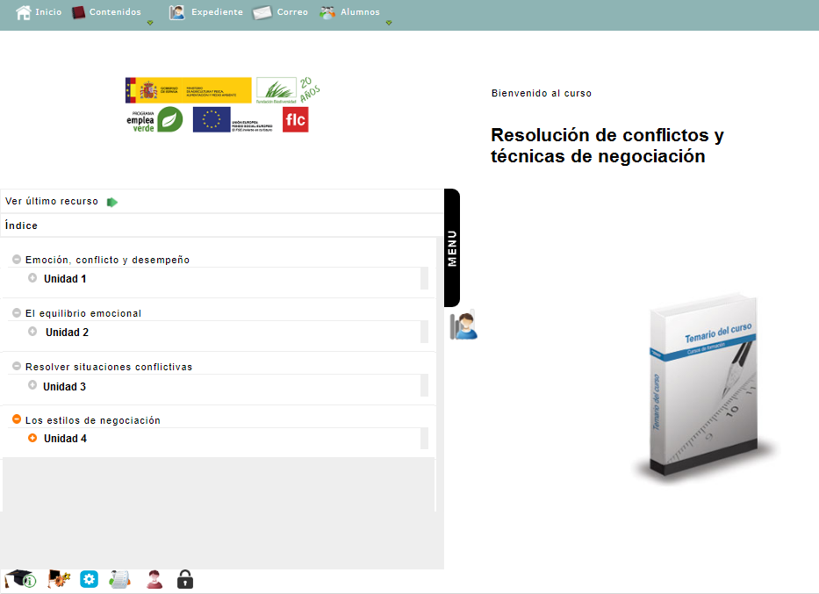
Name of document issued upon completion of the training and assessment
Certificate of participation issued by FLC for students who attended the course but did not pass the training.
Diploma for those who exceeded it.

Number of trainees
18

Dates of training
03/04/2018 y 30/04/2018

RESULT OF THE EVALUATION OF THE EXPERIMENTATIONS

Key findings

Experimentation: Conflicts Resolution and Negotiation Techniques

Title of training / name of VET track
Conflicts Resolution and Negotiation Techniques (Management / Communication)

Pre-training survey
Data were collected from 18 participants, the majority, 83%, correspond to men compared to 17% of women. The age range varies between 25 and 56 years, with 33% of the sample being in their thirties, 56% in their fourties and only 6% under the age of 30 or above the age of 50. The vast majority have university studies (89%) and an average of 12 years of permanence in the company.
The results of the previous survey offer equal results in terms of the reasons why the student has participated in the training:
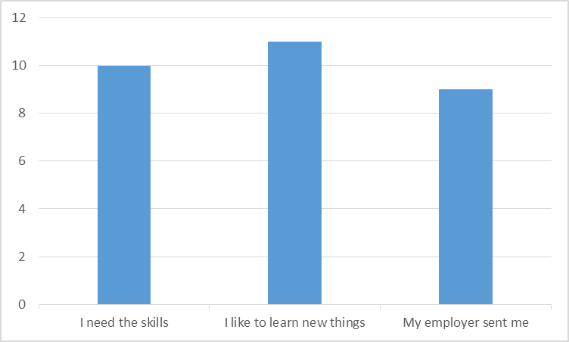
It should be noted that although 33% of the participants were obliged by their chief to undertake the training, of these only 20% wielded this as the only reason, from which it can be deduced that the subject of the training was interesting and motivating for the recipients.
With regard to the expected results of the course, these offer a greater dispersion, being the most common options the acquisition of new skills for the job and learning to solve typical problems at work.
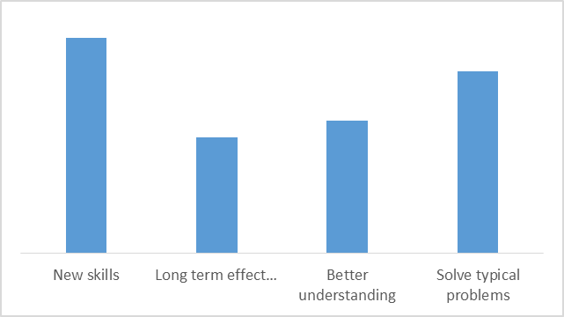

Regarding the didactic resources that the students expected to be used as a methodology in the training, almost the whole (89%) indicated that they expected practical exercises and simulations. The least chosen option was the preparation of group work.
Regarding the expectations generated by each didactic unit, the survey showed the following results:

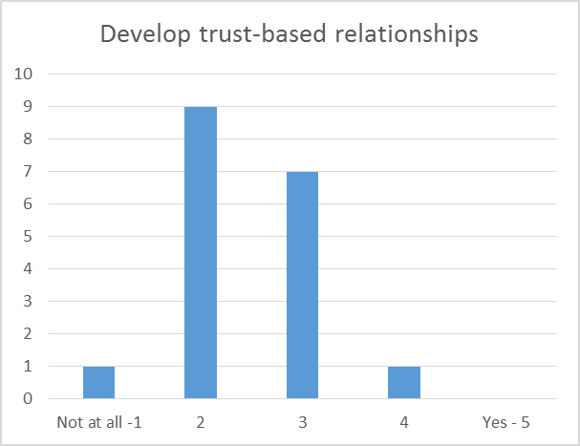 | 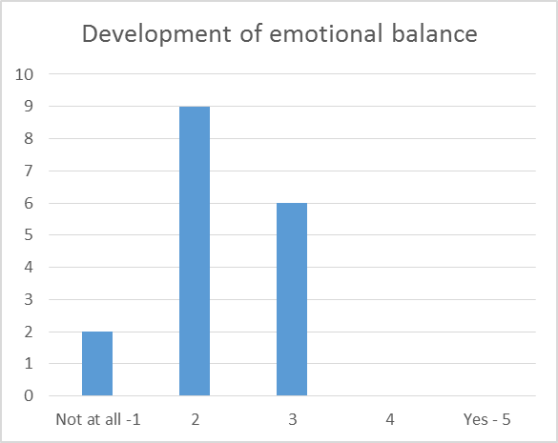
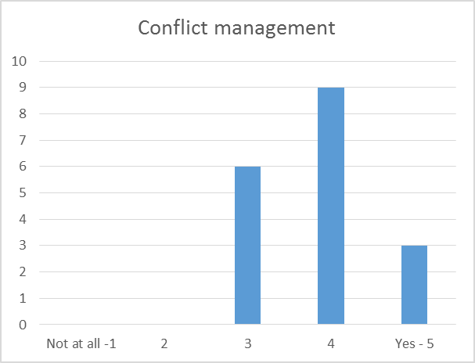
The unit that gave rise to the least expectation of learning was the first, units 3 and 4 being the ones that a priori aroused the greatest interest.
Post-assessment survey
Regarding the participants' own perception of their progress in learning, the values obtained were:

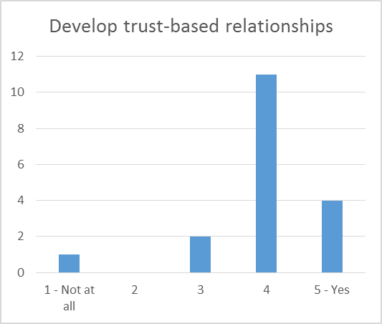 | 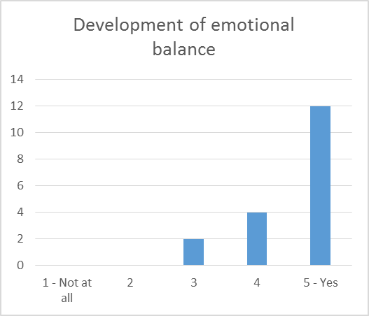
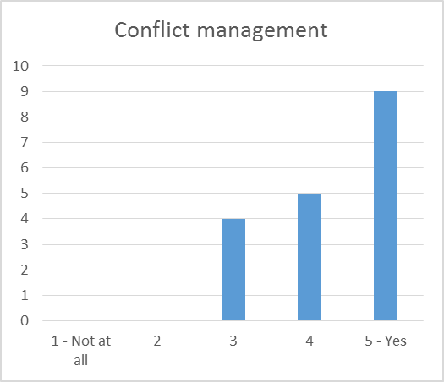 | 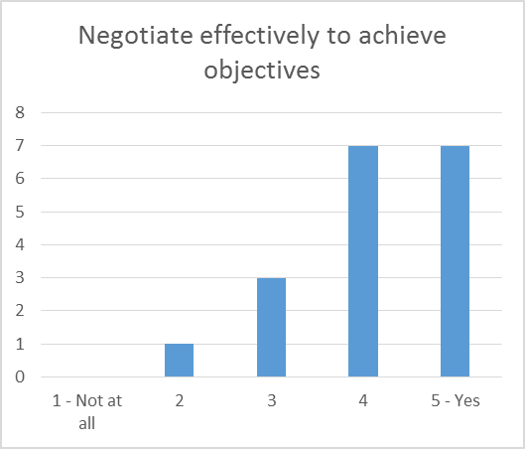

The comparison between the expected values ​​(from the pre-training survey) and the post-training values ​​for the first two teaching units reveal that although initially their contents were unattractive to the participants, they finally managed to arouse their interest and achieve a high level of learning.
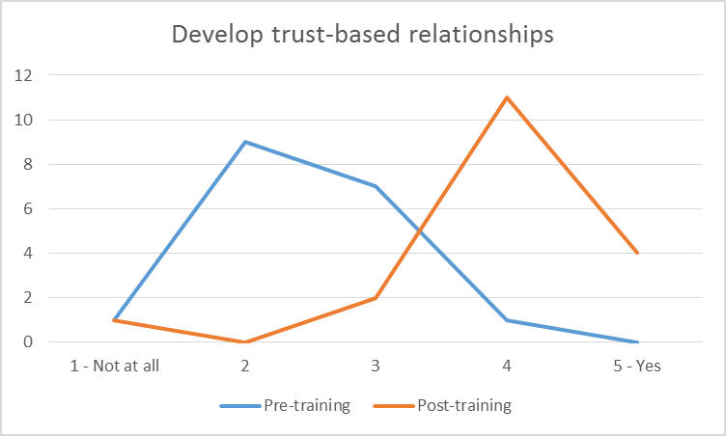 | 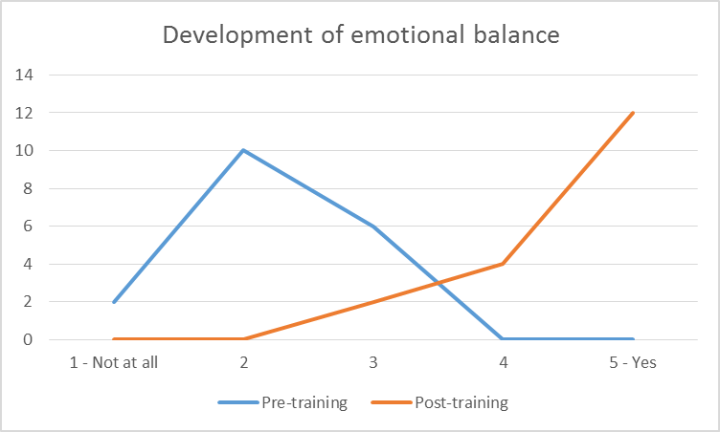
In contrast, the comparative pre-training and post-training for the last two teaching units is more related: both lines describe similar curves. What shows that although the expectations of the students in these units were high, they were fulfilled more than enough.
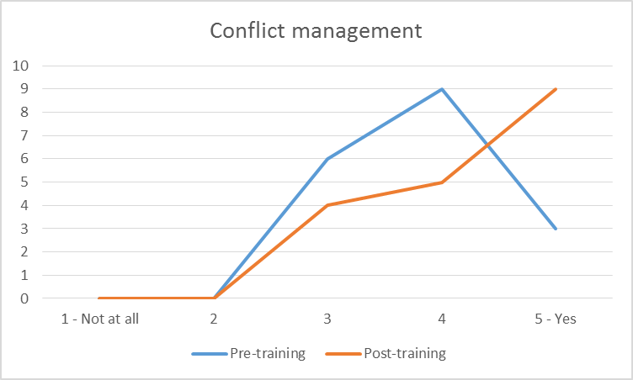 | 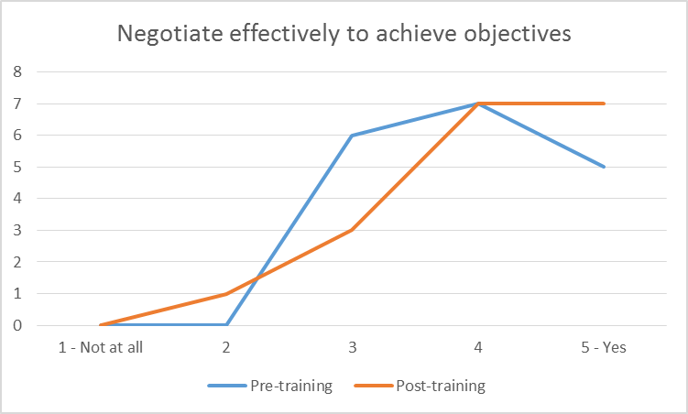

The final survey after the evaluation shows very positive results in general. The majority of the participants (56%) rated the evaluation as "Very useful", 40% as "Useful" and only 5% considered it "Regular" or "Bad". The structure of the evaluation and the evaluators are the items that receive a better evaluation.
The difficulty of the evaluation is assessed as follows:
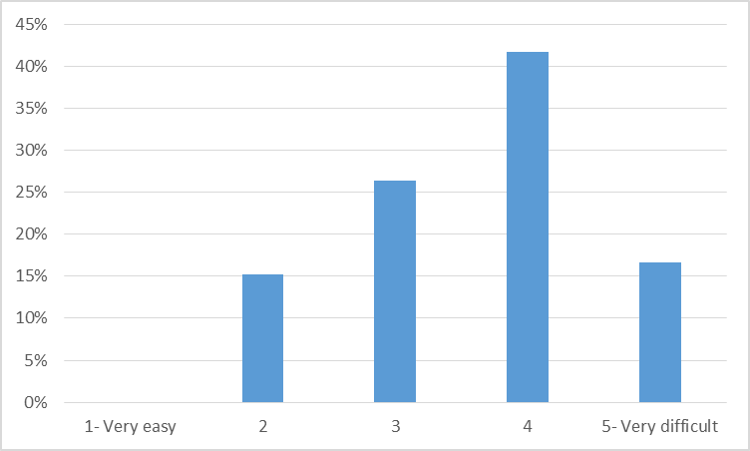

Although scattered results were obtained in this item, no type of evaluation was assessed as "Very easy". The majority (42%) opted for a "Difficult" evaluation, leaving the rest of the options quite similar. The dispersion of results allows us to infer that the difficulty of the evaluation system has been fairly balanced.
The evaluation that turned out to have the greatest difficulty for the participants was the "Discussion exercise / Forum" (33%), whereas the simplest one was the written answers (33%).
From the results of the survey we infer that the evaluation time was well defined: 83% of participants felt that they had enough time to resolve the questions and cases raised.
The value of the evaluators was endorsed with 100% of participants who thought they were very competent. The facilities were also widely rated as adequate (94%), indicating the need to provide the WIFI network space.
Regarding the improvement proposals presented by the participants, the request to include a greater number of practical exercises / role-playing should be highlighted. A student indicates the convenience of expanding the download area of complementary documentation. Several participants request to continue with the training in a second edition of the course and comment that it was short.

Interviews with participants
Once the training is completed, a group interview is conducted with the participants to assess it as a whole. The total number of recipients attend this final evaluation session.
The participants point out that the weak point of the training lies in the duration assigned to the face-to-face sessions. The majority indicate that they would have liked to have an extra face-to-face time to have the opportunity to discuss in a group the personal experiences of each participant. The opinion that sharing these experiences was very enriching and motivating is unanimous.
The most valued part of the training turned out to be the didactic material that was used in the course and the professionalism of the teachers who managed to motivate students and arouse their interest in the content of the course. Many students also highlight the good group atmosphere that existed during the sessions.
Regarding the most surprising content they learned during the training, there are two that stand out especially; one linked to conflict and the other to negotiation. Regarding the first one, the students emphasize that they have learned not to perceive conflict with a negative connotation, but rather as a situation that is part of life and human relationships and that it is therfore necessary to know how to manage it. Regarding the second, they have discovered the value of empathy as an initial and fundamental attitude in the negotiation process. They also found it surprising to know the systems of nonverbal communication, especially those related to body posture, its direct relationship with the feelings and emotions of the interlocutor.
The improvements that were proposed were always in the line of adding more practical cases to the didactic material, in particular, more real cases of conflict resolution were demanded. The students valued collaborative activities or group resolution very positively.
The importance of listening and observation is the content that is indicated as most useful by a large group of students; another group indicates the course has helped put themselves in the place of the other before making decisions or acting.
Assertiveness and negotiation skills are two of the skills that have improved the learning group as a whole.
The vast majority of students say that they will apply the techniques and methods learned in their work environment. Almost all agree that the construction activity is a sector in which they do not usually make use of social skills to resolve conflicts and that this has been a training that has helped them to gain confidence in that field since they have learned techniques that will allow them to adequately handle situations of explicit and / or implicit confrontation.
Regarding the evaluation of the training, the participants express their agreement with the chosen evaluation system. They comment that it is very diverse and includes various types of tests (written, practical cases, simulations ...), thus making it very attractive. They highlight the difficulty of the exercises presented in the forum and comment that reaching an agreement between very different points of view was not always easy. For the majority the written questions were the easiest to resolve. Regarding the simulations, they comment that they were very motivating and facilitated the subsequent dialogue and learning.
A general concern among the beneficiaries is revealed: the possible lack of continuity in training. Several students express their will to continue their training in the field of these competences.

Interviews with partners
Target group: Collaborating entities.
Date of completion: at the end of the training activities.
A session was held among the different entities participating in the project to know their impressions in relation to the training modules implemented on Conflict Resolution and Negotiation, aimed at the qualification of middle managers in the construction industry.
The general opinion about the need for this training is that they consider it as very necessary due to the typology of the work carried out as a team and in many cases with very different professional profiles, which requires mutual cooperation to solve the tasks.
This work environment can lead to situations of conflict that are aggravated by very short delivery times and different professional and business interests.
With regard to the benefits that this training can bring, it is observed that for the companies it can suppose a better working climate, greater worker satisfaction and, in short, optimized execution processes that will also benefit the result of the execution of the work.
An important improvement has been noticed with regard to the acquisition of skills, especially in active listening, putting oneself in the place of the other, empathy and capacity for dialogue and understanding to solve problematic situations.
Participants have realized that the acquisition of these transversal skills have been as important as the techniques for the development of their work, since the company itself values ​​that the activities should be carried out in a coordinated way between the different professionals who develop them.
An observed case has been provided once the training in relation to the order and cleanliness of the work environment has been completed, recognizing the importance of leaving the workspace in adequate conditions so that the next unit of work is done properly and thus, avoiding conflict between workers of different specialties.
The middle managers now recognize the importance of listening to subordinates before giving orders to avoid situations that may lead to conflict between the two parties. For example, in a situation where the workers' request for reduction of meal time was taken into account, it was possible to improve both the work-family reconciliation of the workers and the entry into the workplace of the next provider.
After training, the students now understand that before carrying out the tasks that the construction site requires, it is important to foster dialogue and understanding with the workers who are going to carry them out.

Key findings
Ver anexo 1: ES_Pre-assessment survey
Ver anexo 2: ES_Post-assessment survey

CONCLUSIONS FOR THE COMBINED EVALUTATION MODEL
Once the statistical analysis of the surveys and interviews with participants and collaborators has been completed, the combined evaluation model can be approached as a procedure to ensure that the distortion caused by biases and personal feelings of any of the members of both groups is minimized.
The data obtained from this model allow the following conclusions to be drawn:
- In general terms, the evaluation system is valued in a positive way. It is appreciated in the opinions expressed that the system allows to verify the progress of learning adequately. The students do not perceive the evaluation as an error detection system, but as an aid to improve their level of understanding of the knowledge transmitted.
- A formative and participatory vision of the evaluation is appreciated among the subjects. The researched group considers that the evaluation system is a learning opportunity that generates greater understanding of the knowledge transmitted and favors their participation, which facilitates that the accumulated knowledge is shared, developing in this way a know-how that constitutes one of the most valued items.
- All the subjects involved propose to enrich the evaluation system with the contribution of various sources of information and practical cases. It is common opinion that the diversity of sources and the increase of proposed exercises will provide the possibility of increasing the transfer to the job of the strategies learned.
- The target group, despite its heterogeneity, reveals itself as a cohesive group. There are no significant differences between the ratings of the older group and the youngest. Neither significant differences are appreciated depending on the gender. This allows us to infer that the contents taught are really transversal for all construction professionals and constitute a common training need that needs to be met.
Based on the conclusions drawn, it can be affirmed that training in the field of conflict resolution and negotiation has resulted:
- Relevant. The competences treated have proved to be critical for the selected professional profiles. Almost all the participants did not know the strategies to face a conflict or to lead a negotiation.
- Effective. Since the initially proposed objectives have been reached.
- Efficient. The impact that the training has achieved has been verified since the participants have managed to transfer what they have learned to their professional reality.

